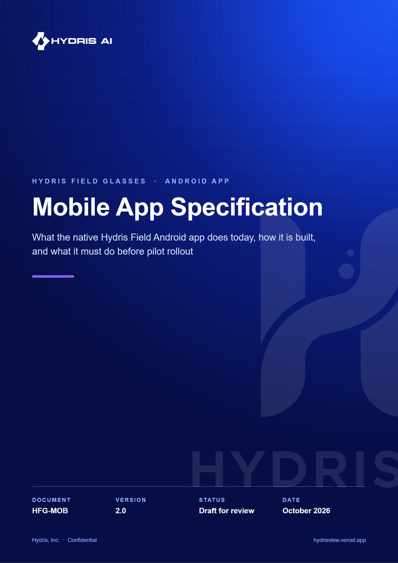
Document control
Document | Mobile App Specification (HFG-MOB)
Version | 2.0
Status | Draft for review
Owner | Mobile engineering, Hydris
Audience | Mobile and backend engineering, product, design, QA, pilot customer IT
Product | Hydris Field Glasses: website, operator console, glasses app, Android app, API
Source of truth | docs/product/MOBILE_APP_SPEC.md in tarun-km/hydrisview (this Word file is generated from it)
Classification | Confidential: Hydris, Inc. and named partners
Revision history
Version | Date | Author | Changes
2.0 | October 2026 | Mobile engineering, Hydris | Rewritten against the native app in apps/android (Kotlin, Compose, CameraX, ML Kit, Meta DAT 1.0.1) with screen specs, state models, pipelines, diagrams and an honest Built / Partial / Planned status for every feature

Contents
1 Product summary and goals 6
1.1 Who the app is for 6
1.2 Goals 6
1.3 Non-goals 7
1.4 Success measures (targets, not measured results) 7
2 Relationship to the Meta AI app 8
2.1 What Meta requires 8
2.2 Product position 8
3 Architecture 10
3.1 Technology stack 10
3.2 Layers 11
3.3 Package and file inventory 11
3.4 Core classes 12
3.5 State management pattern 13
4 Navigation 14
4.1 Navigation map 14
4.2 Session gate 15
5 Screen specifications 16
5.1 Login 16
5.2 Home 18
5.3 Hydris assistant 20
5.4 Work 22
5.5 Alarm detail 24
5.6 Sensor detail 26
5.7 Scan 27
5.8 Glasses 31
6 Data layer and networking 34
6.1 API client 34
6.2 Session model 34
6.3 Refresh on 401 with a mutex 35
6.4 Device credential channel 36
6.5 Repository 36
6.6 Registering glasses as a Hydris device 37
6.7 Realtime events (SSE) 38
7 Audit scan pipeline 40
7.1 End-to-end flow 40
7.2 Page detection (DocDetect) 41
7.3 Guidance 41
7.4 Stability and auto-capture 43
7.5 Capture and flattening 43
7.6 On-device OCR (OcrEngine) 43
7.7 Label and value pairing on the review card 45
7.8 Upload limits 45
8 Voice 46
8.1 Speech sources 46
8.2 Speech output 46
8.3 Language 46
9 Notifications 47
10 Permissions 48
10.1 Permission matrix 48
10.2 Glasses permission round trip 48
11 Design system 49
11.1 Colour tokens 49
11.2 Typography, shape and spacing 49
11.3 Components 50
12 Accessibility 51
13 Performance budgets 52
14 Offline behaviour and sync 53
14.1 Today 53
14.2 Planned 53
15 Security 54
16 Build and release 55
16.1 Project setup 55
16.2 DAT credentials and Developer Mode 55
16.3 Release channels 56
17 Testing 58
17.1 Current state 58
17.2 Test plan 58
18 Feature status and roadmap 59
18.1 Status summary 59
18.2 Open questions 60

Hydris Field is the native Android app that field operators carry on shift. It signs in with the same Hydris account as the web console, shows the plant dashboard, alarms, work and live sensor charts, scans paper audit records into verified digital documents, answers spoken questions ("Hey Hydris") from live plant data, and connects Ray-Ban Meta glasses through Meta's Wearables Device Access Toolkit (DAT). This specification describes the app as it exists in apps/android on main, and marks every capability Built, Partial or Planned.
The previous edition of this document (version 1) described a target architecture before any code existed. Version 2 replaces it: the app is now written, and where the code differs from the earlier plan (no Hilt, no Room, no ViewModels yet, a single Gradle module), this document follows the code and records the earlier plan as Planned work.
5  Bottom tabs  Home, Work, Scan, Hydris, Glasses |  | 7  Navigation routes  `Root.kt` NavHost |  | 2  OCR passes per page  original and enhanced, on device |  | 31  Minimum SDK  Android 12

NOTE
Source of truth for this document: apps/android/app/build.gradle.kts, AndroidManifest.xml and the Kotlin sources under apps/android/app/src/main/java/ai/hydris/field/. File names are given relative to that package unless stated otherwise. Screenshots in this document were taken from a debug build on an Android emulator against the demo deployment, so the Glasses screen shows the "Meta AI app not installed" state.

1 Product summary and goals

1.1 Who the app is for
The primary user is the field operator (role field_operator): the person walking rounds in an effluent or sewage treatment plant, reading gauges, acknowledging alarms and filling paper logs. Secondary users are maintenance engineers (work orders, checklists) and supervisors who want the plant status in their pocket. All of them already have a Hydris console account; the app adds no new identity.

1.2 Goals
ID | Goal | Status | Evidence
MOB-G01 | One account everywhere: sign in with the console credentials and see the same organization, sites and data | Built | HydrisApi.login, Repository calls the shared /api
MOB-G02 | Plant status at a glance: open alarms, inspections due, maintenance, live measurements, alarm trend, asset health | Built | HomeScreen.kt over GET /overview
MOB-G03 | Act on alarms from the field: acknowledge, investigate, resolve, close | Built | AlarmDetailScreen in WorkScreen.kt
MOB-G04 | Turn a paper record into a verified digital document in under a minute | Built | ScanScreen.kt, scan/DocDetect.kt, scan/OcrEngine.kt
MOB-G05 | Hands-free questions answered from live data, spoken back | Built | AskScreen.kt, voice/VoiceEngine.kt
MOB-G06 | Glasses are optional: every glasses feature has a phone fallback | Built | Phone camera, phone microphone and phone speaker paths in ScanScreen.kt and VoiceEngine.kt
MOB-G07 | Connect Ray-Ban Meta glasses and register them as a Hydris device so scans are attributed | Built (not verified on hardware) | glasses/GlassesManager.kt, Repository.registerGlasses
MOB-G08 | Critical and high alarms reach the operator's phone in real time | Partial (foreground process only) | SSE in Root.kt, channel in HydrisApp.kt
MOB-G09 | Work offline on a round and sync later | Planned | No local cache or outbox yet

1.3 Non-goals
- Replacing the Meta AI app. It is impossible under DAT and is not attempted (see the next chapter).
- Equipment control. The app never writes set points or commands to plant equipment. It reads telemetry and records human actions.
- Administration. Members, roles, sites, alarm rules, UI profiles and device revocation stay in the web console.
- Audit document review and approval. Reviewers confirm each value against the paper in the console. The app captures and sends; it does not approve.
- iOS in this release. The web glasses viewport already supports an iOS host through window.HydrisWearables, but there is no native iOS app.
- Rendering a HUD on the glasses. Ray-Ban Meta and Oakley Meta glasses have no display. On them the phone is the screen and the glasses are a camera, microphone, speaker and button.

1.4 Success measures (targets, not measured results)
Measure | Target | How it will be measured
Time from opening Scan to "Sent" for a one-page A4 record | Under 60 s on a mid-range phone | Pilot telemetry (Planned event logging) and stopwatch tests in QA
Share of scans that auto-capture without "Capture now" | Above 70 % | Planned client event scan.autocapture
Critical alarm to phone notification | Under 5 s while the app process is alive | QA with the alarm simulator
Spoken answer latency after the question ends | Under 3 s on 4G | QA script with fixed questions
Crash-free sessions in pilot | Above 99.5 % | Play Console vitals (Planned)

2 Relationship to the Meta AI app

2.1 What Meta requires
Ray-Ban Meta glasses are paired to a phone in Meta's Meta AI app (Android package com.facebook.stella). Meta's DAT FAQ states that "the Meta AI app must be used to pair your glasses", including for apps that process data elsewhere. Developer Mode, which lets an unpublished app connect to the glasses, is also switched on inside the Meta AI app. Meta's setup guide describes the toggle as hidden: Settings, App Info, then tap the app version number five times. Glasses firmware is updated through the Meta AI app, and DAT publishes a version dependency table that the Meta AI app and firmware must satisfy.
When Hydris Field calls Wearables.startRegistration(activity), the Meta AI app opens so the wearer can approve Hydris, then returns to Hydris Field. The same happens when Hydris asks for a glasses capability permission (camera or microphone) through Wearables.RequestPermissionContract().

2.2 Product position
DECISION
Hydris Field does not replace the Meta AI app. The Meta AI app stays installed and signed in on every operator phone that uses glasses. It pairs the glasses, approves Hydris as a connected app, grants camera and microphone access and updates firmware. After that one-time setup, operators open only Hydris Field; the Meta AI app works in the background as the connection broker.

The app makes this dependency visible instead of hiding it:
- GlassesManager.metaAiInstalled() checks for com.facebook.stella through the package manager. The manifest declares a <queries> entry for that package so the check works on Android 11 and later.
- If the Meta AI app is missing, "Connect glasses" does not call DAT. It shows: "Install the Meta AI app and pair your glasses in it first - Hydris connects through it." (see the Glasses screen chapter).
- Step 1 on the Glasses screen is titled "Link with the Meta AI app" and tells the user to keep it installed.
Table 1. Which app owns which responsibility
Responsibility | Meta AI app | Hydris Field
Bluetooth pairing of the glasses to the phone | Owns | Never touches
Glasses firmware updates | Owns | Shows errors reported by DAT
Developer Mode toggle | Owns | Documents the step
Approving Hydris as a connected app (registration) | Shows the prompt | Starts it with startRegistration
Camera and microphone permission for Hydris | Shows the prompt | Requests it with RequestPermissionContract
Camera stream, photo capture, capture button, speech | Brokers the link | Consumes through DAT sessions
Hydris account, plant data, scans, alarms, voice answers | Not involved | Owns
Registering the glasses as a Hydris device | Not involved | Owns (pairing endpoints)

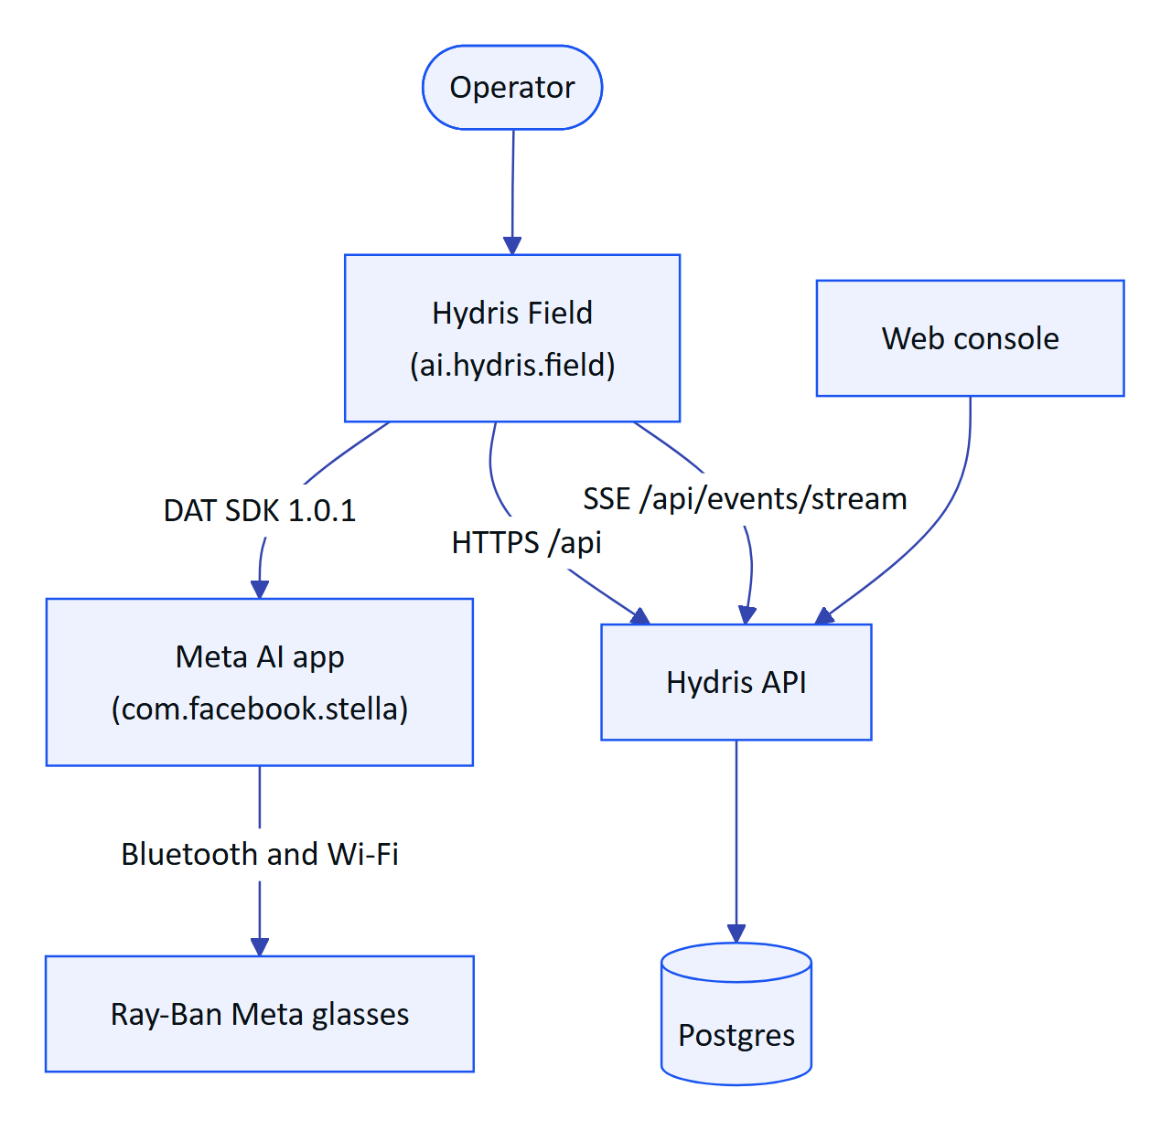
Figure 1. Where Hydris Field sits between the operator, Meta's stack and the Hydris platform

3 Architecture

3.1 Technology stack
Table 2. Technology choices as built (apps/android/app/build.gradle.kts, settings.gradle.kts)
Concern | Choice | Version | Status
Language | Kotlin, JVM target 17 | 2.2.21 | Built
Build | Android Gradle Plugin, Gradle wrapper | AGP 8.11.1, Gradle 8.14.3 | Built
SDK levels | minSdk 31 (Android 12), compileSdk and targetSdk 36 |  | Built
UI | Jetpack Compose, Material 3, Material icons extended | Compose BOM 2026.05.01 | Built
Navigation | navigation-compose, single activity | 2.9.5 | Built
Concurrency | Kotlin coroutines and Flow | 1.10.2 | Built
Serialization | kotlinx-serialization-json | 1.9.0 | Built
HTTP and SSE | OkHttp (one client, one SSE client without read timeout) | 4.12.0 | Built
Secrets | Android Keystore AES-256-GCM over SharedPreferences (data/SecureStore.kt) | Platform | Built
Preferences | datastore-preferences | 1.1.7 | Partial: declared, not used yet
Camera | CameraX camera2, lifecycle, view | 1.4.2 | Built
OCR | ML Kit Text Recognition (Latin) | 16.0.1 | Built
Image metadata | androidx.exifinterface | 1.4.2 | Built
Glasses | Meta DAT mwdat-core, mwdat-camera, mwdat-speech, mwdat-inputs; mwdat-mockdevice in debug | 1.0.1 | Built (not hardware-verified)
Charts | Hand-drawn Compose Canvas (Sparkline, LineChart, Bars, Donut) |  | Built
Dependency injection | None: app-wide singletons on HydrisApp |  | Built (Hilt is Planned)
Local database | None |  | Planned (Room)
Push | None (SSE only) |  | Planned (FCM)

NOTE
Meta's setup guide lists Android 10 as the DAT minimum. Hydris Field sets minSdk = 31 (Android 12) on purpose: it matches the DAT sample apps and the existing bridge app, and Android 12 introduced the BLUETOOTH_CONNECT runtime permission the app is designed around.

3.2 Layers
The app is one Gradle module (:app) organized in packages. Screens are composable functions that hold their own UI state and call the Repository through a small rememberLoad helper. There is no ViewModel layer yet; long-lived state (session, glasses link, voice) lives in singletons created once in HydrisApp.onCreate.
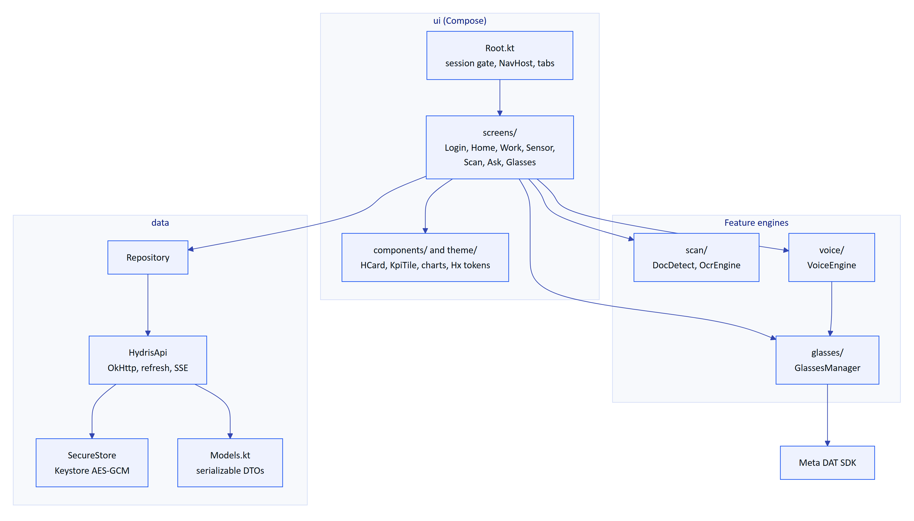
Figure 2. Layers and packages in apps/android

3.3 Package and file inventory
Table 3. Kotlin sources and their responsibilities
File | Lines (approx.) | Responsibility
MainActivity.kt | 64 | Single activity. Edge-to-edge dark system bars. Launches Bluetooth and notification permissions on every onStart. Bridges DAT permission requests (Meta AI app round trip) and phone camera or microphone permissions into suspend functions
HydrisApp.kt | 31 | Application. Creates HydrisApi, Repository, GlassesManager, VoiceEngine; registers the alarms notification channel
data/HydrisApi.kt | 179 | HTTP client, session refresh, encrypted cookie jar, device token channel, SSE event stream
data/Repository.kt | 71 | Every API call the screens use; scan upload; glasses registration flow
data/Models.kt | 119 | @Serializable DTOs mirroring apps/api/src/modules
data/SecureStore.kt | 53 | Encrypted key/value store
scan/DocDetect.kt | 226 | A4 page detection, guidance, motion, homography warp (port of apps/web/src/lib/docdetect.ts)
scan/OcrEngine.kt | 115 | Upload sizing, two ML Kit passes, image enhancement
glasses/GlassesManager.kt | 305 | DAT initialization, registration, session, camera, photo, capture button, speech
voice/VoiceEngine.kt | 132 | Speech input (glasses or phone) and TextToSpeech output
ui/Root.kt | 142 | Session restore, login gate, bottom navigation, realtime alarm notifications
ui/theme/Theme.kt | 58 | Hx colour tokens, Material colour scheme, typography
ui/components/Components.kt | 208 | Cards, chips, KPI tiles, progress bar, charts, time formatting
ui/screens/*.kt | 1,300 | Seven screens plus Common.kt (rememberLoad)

3.4 Core classes
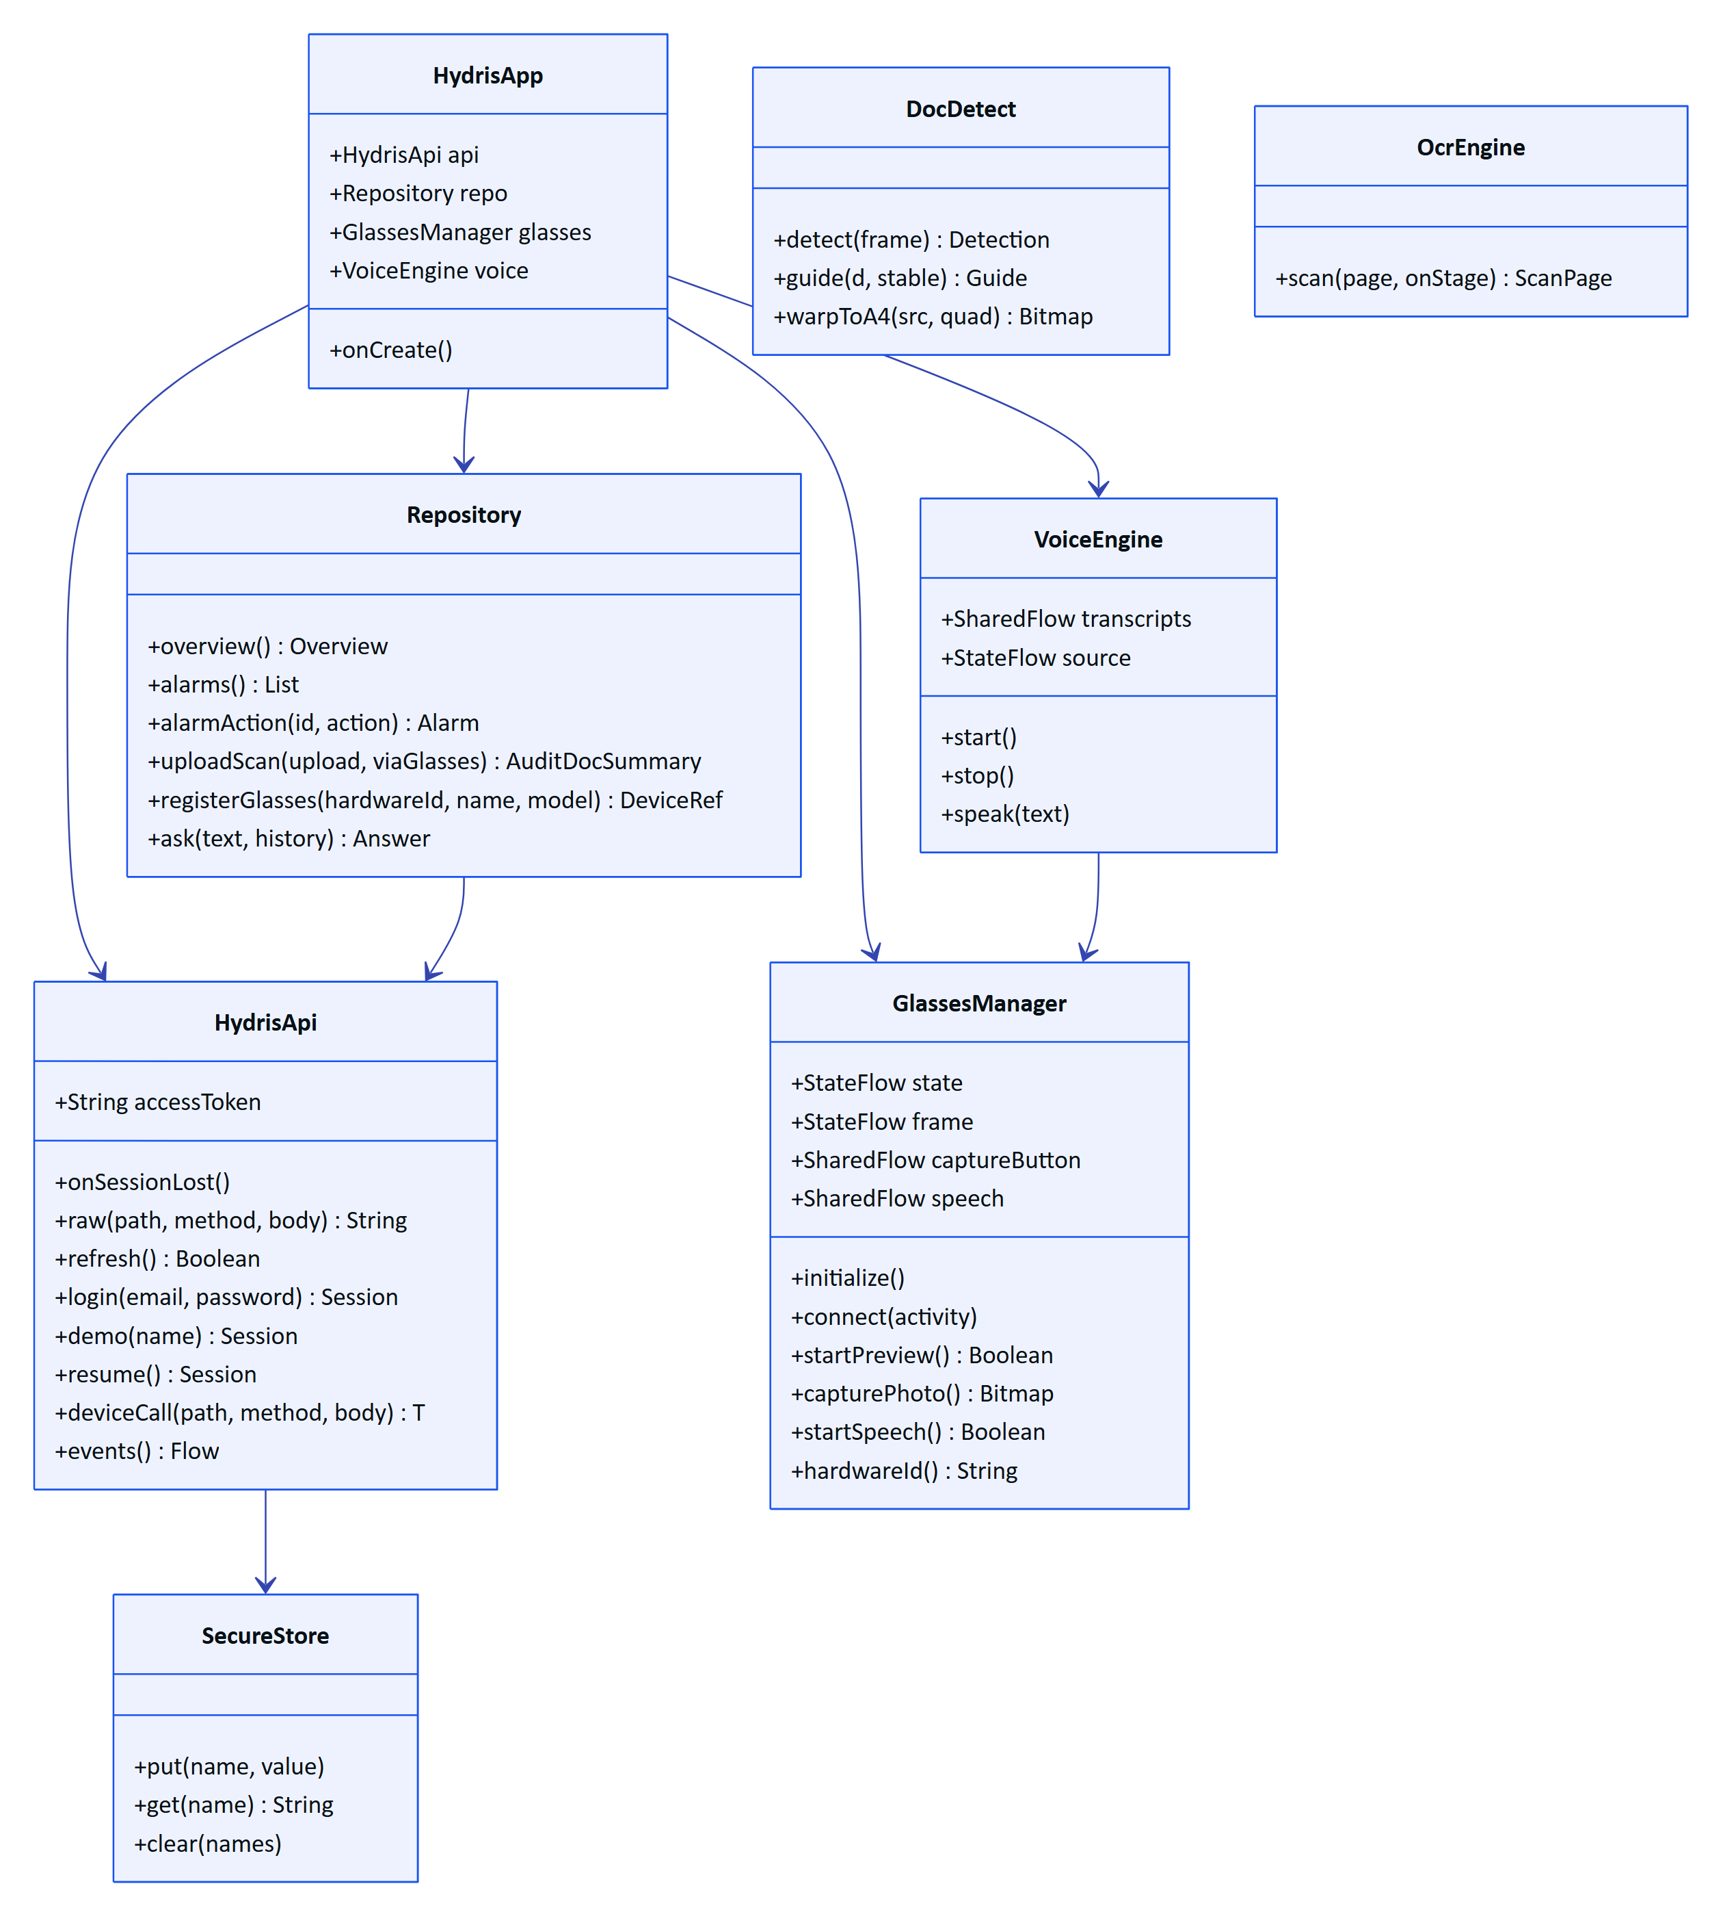
Figure 3. Main classes and how they depend on each other

3.5 State management pattern
Screens load data through rememberLoad in ui/screens/Common.kt. It returns a Loadable with three Compose states (data, error, nonce) and runs the loader in a LaunchedEffect keyed on the caller's keys and the nonce. When refreshMs is set, it loops with delay(refreshMs) for as long as the screen is composed, which is how live screens poll. reload() increments the nonce to force a reload, for example after an alarm action or a checklist toggle.
Table 4. Polling intervals per screen (from the refreshMs arguments)
Screen or tab | Loader | Refresh
Home | overview() | 15 s
Work, Alarms tab | alarms() without closed alarms | 15 s
Work, Inspections tab | inspections() | On open only
Work, Maintenance tab | tasks() without completed and cancelled | On open and after each toggle
Work, Sensors tab | sensors() | 10 s
Work, Audit docs tab | auditDocs() | 20 s
Sensor detail | history(id, hours) | 15 s
Alarm detail | alarm(id) | On open and after each action
Scan menu, recent scans | auditDocs().take(4) | On open only

DECISION
Polling plus SSE is deliberate for the pilot. It keeps every screen correct after network drops without a local database, at the cost of extra requests while a screen is visible. The Planned offline work (Room cache and outbox) will move these loaders behind ViewModels and repositories that serve cached data first.

4 Navigation

4.1 Navigation map
Root.kt decides between three top-level states: restoring a session, signed out (Login) and signed in (Main). Main hosts a Scaffold with a Material 3 NavigationBar and a NavHost whose start destination is home. Tab navigation pops back to home with saved and restored state, so each tab keeps its scroll position.
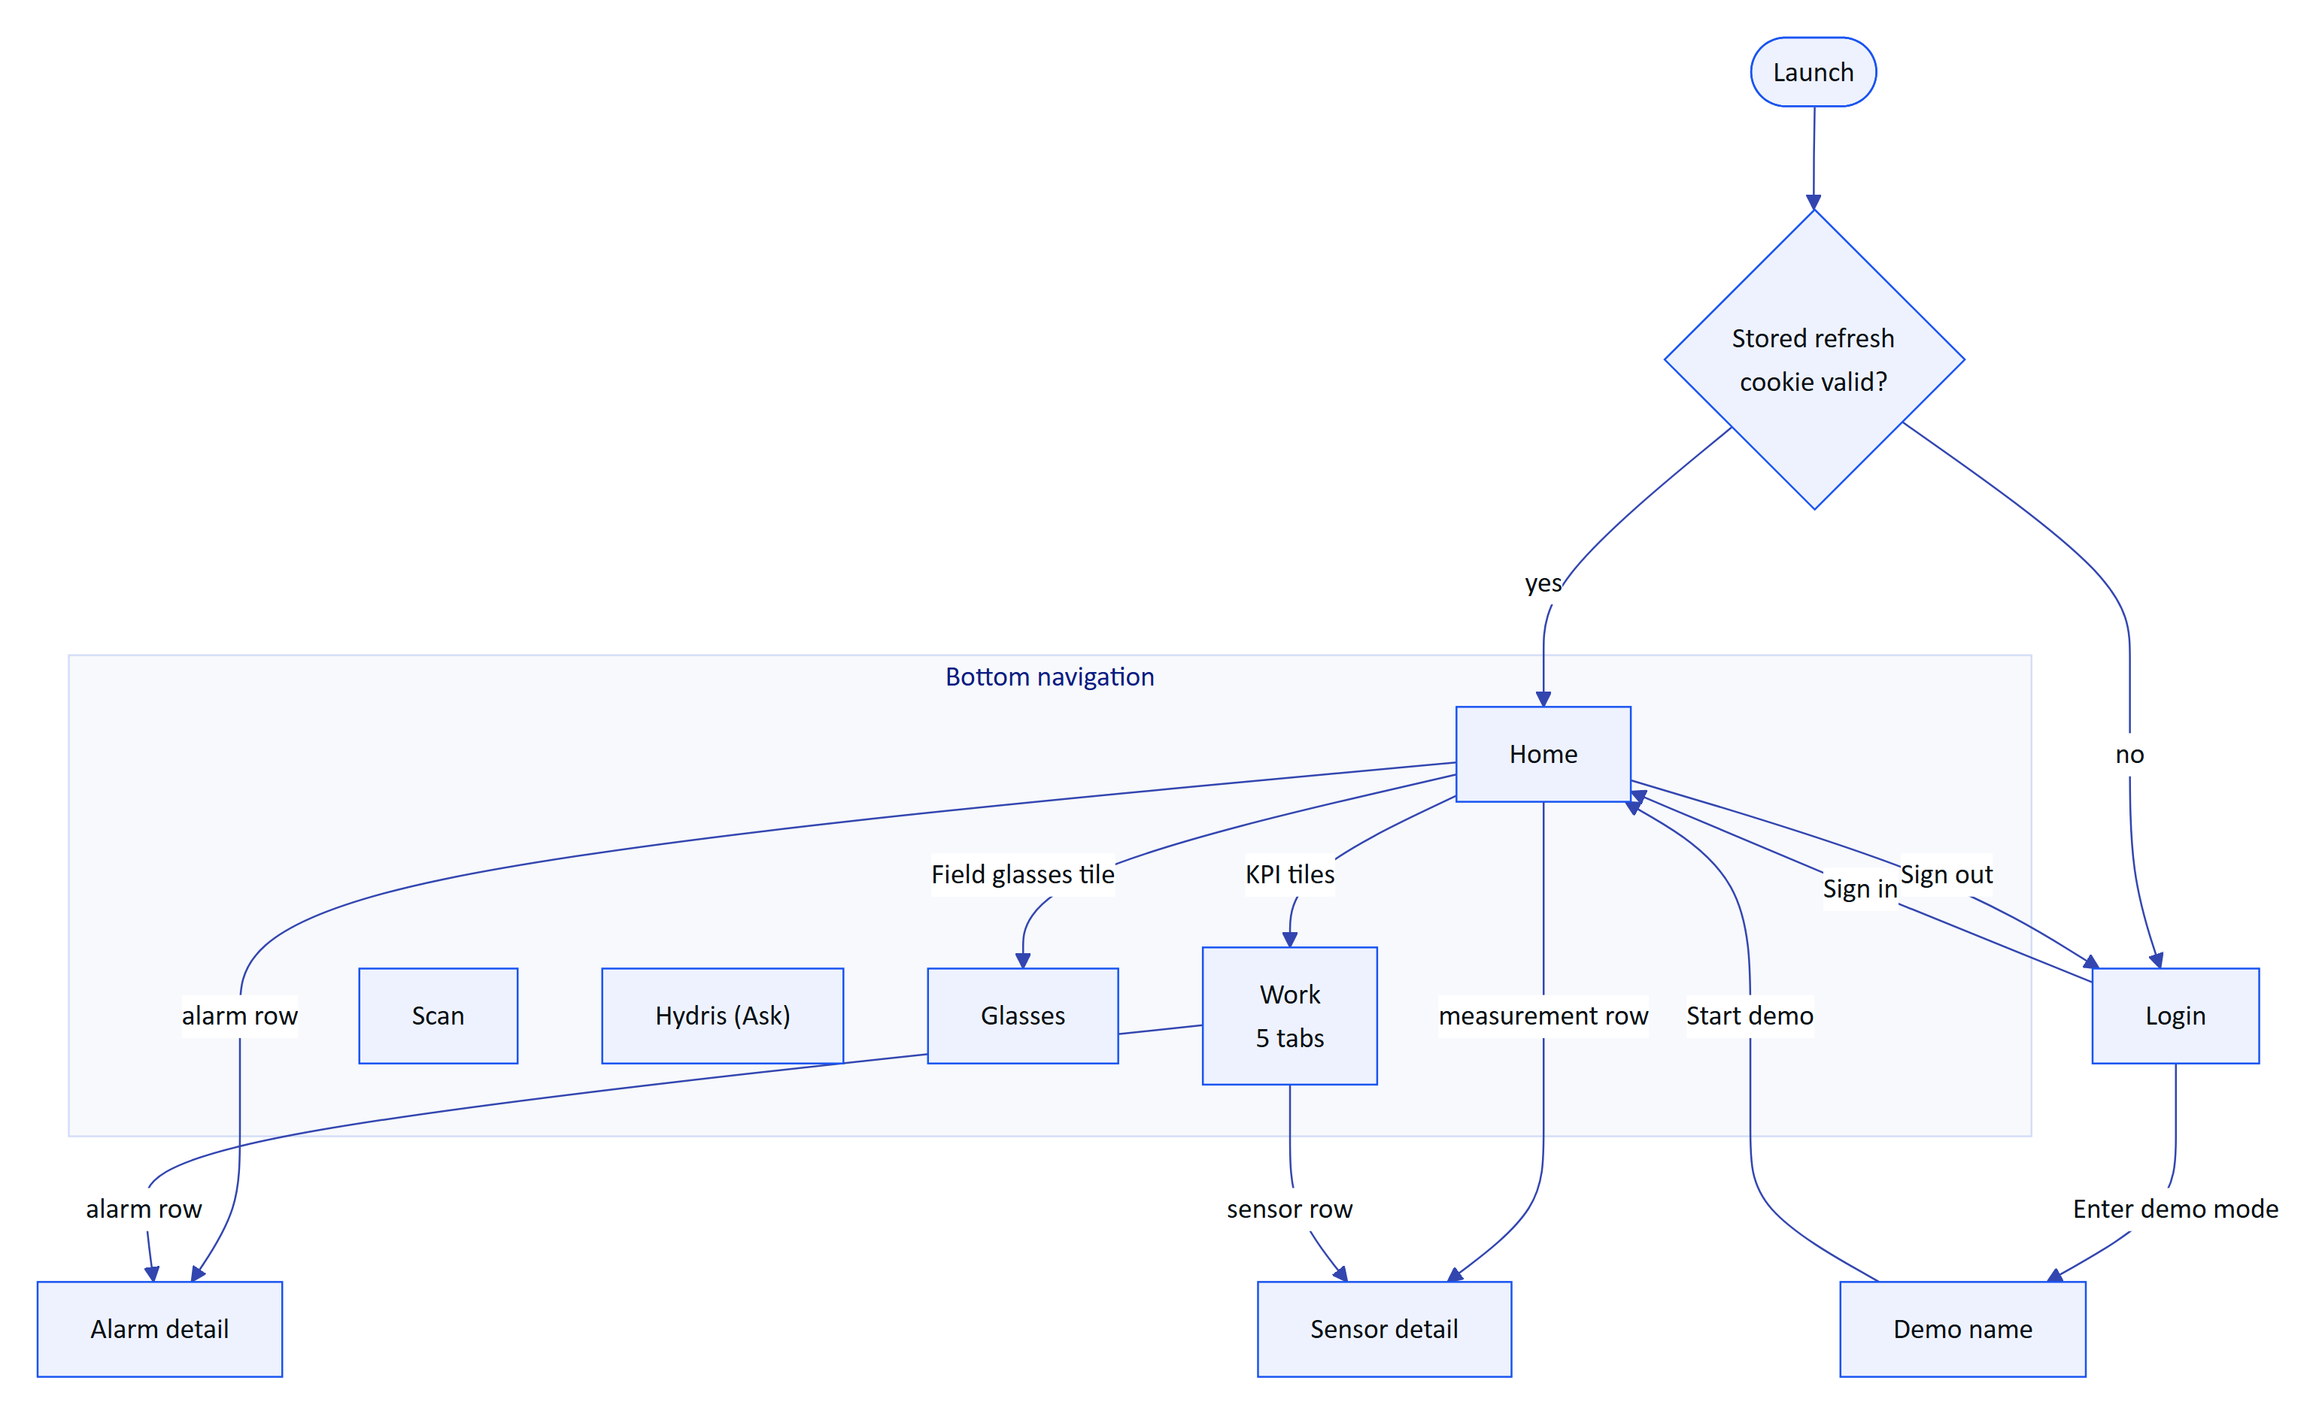
Figure 4. Navigation map of the app as built
Table 5. Routes registered in the NavHost
Route | Screen | Arguments | Entry points
home | HomeScreen | none | Start destination, Home tab
work | WorkScreen | none | Work tab, Home KPI tiles, Home "All sensors" link
scan | ScanScreen | none | Scan tab
ask | AskScreen | none | Hydris tab
glasses | GlassesScreen | none | Glasses tab, Home "Field glasses" tile
alarm/{id} | AlarmDetailScreen | alarm UUID | Home recent alarms, Work alarms tab
sensor/{id} | SensorScreen | sensor UUID | Home live measurements, Work sensors tab

WARNING
Known gap: the Home "All sensors" link navigates to work, which opens on the Alarms tab, not the Sensors tab. The fix is to pass the tab index as a route argument (work?tab=3). Planned for the next build.

4.2 Session gate
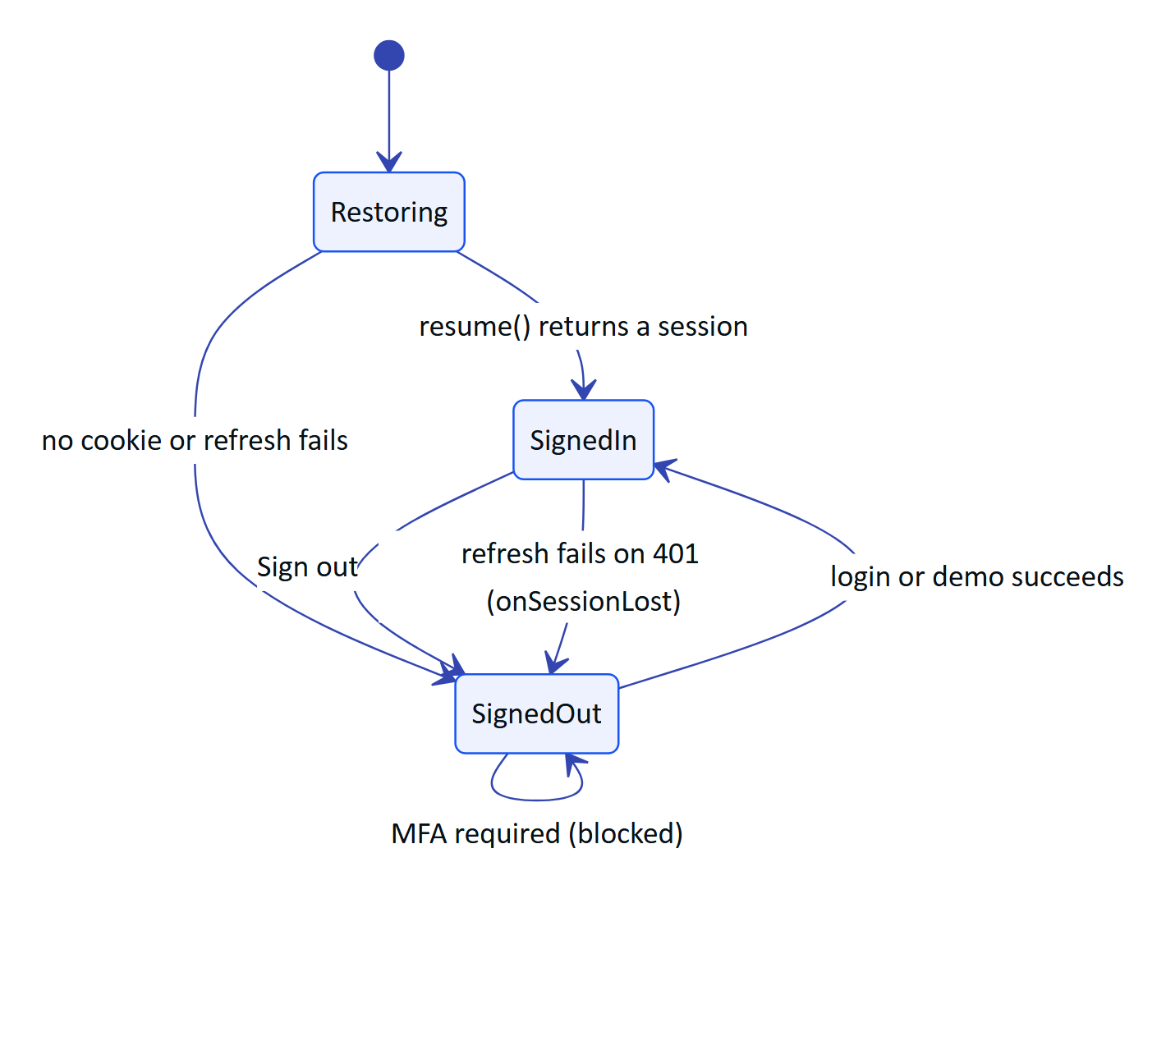
Figure 5. Top-level session states in Root.kt
While Restoring, the app shows a centred progress indicator on the Deep Midnight background. HydrisApi.resume() calls refresh() (which sends the stored hg_refresh cookie) and then GET /auth/me. If either fails, the user lands on Login. onSessionLost is installed after restore, so any later 401 that cannot be refreshed returns the user to Login.

5 Screen specifications
Each screen below lists its purpose, layout, data, state model, actions and status. Screenshots are from the demo deployment (hydrisview.vercel.app).

5.1 Login
Purpose. Sign in with the console account, or start a personal demo account.
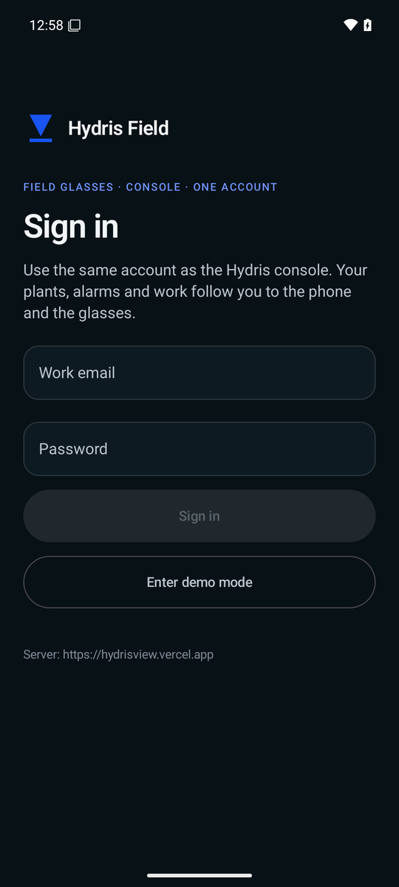
Figure 6. Login screen with work email and password
Layout. Hydris mark and "Hydris Field" title, eyebrow "Field glasses · console · one account", "Sign in" headline and a one-line explanation. Email field (email keyboard), password field (masked), primary button "Sign in" (54 dp high, Signal Blue), outlined button "Enter demo mode". The configured server URL (BuildConfig.HYDRIS_URL) is printed at the bottom so pilots can see which deployment the build points at.
Demo mode. Tapping "Enter demo mode" swaps the form for a single "Your name" field with the explanation "Demo mode creates a personal account with synthetic plant data, your own inspections and tasks." "Start demo" is enabled when the trimmed name has at least two characters and calls POST /auth/demo {name}.
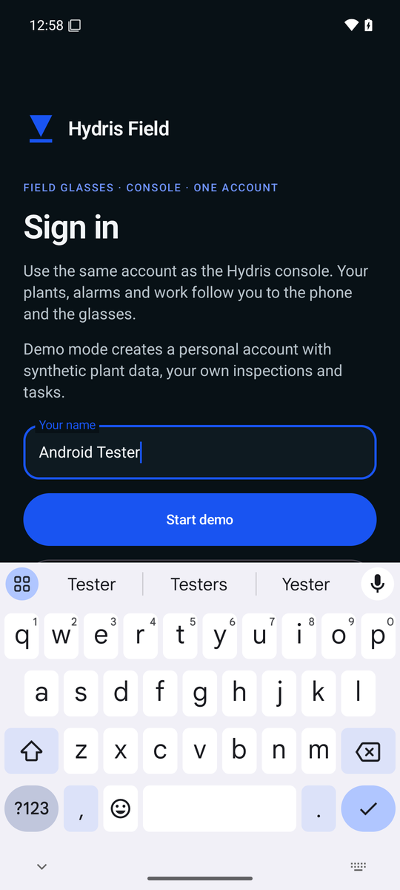
Figure 7. Demo mode asks only for a name
Table 6. Login states
State | Trigger | UI
Idle | Screen opens | Buttons enabled when email is not blank and password is not empty
Busy | Sign in or Start demo tapped | Button text "Signing in…" or "Starting…", buttons disabled
Error | API error | ErrorNote with the server message (for example invalid credentials or lockout)
MFA required | Session.mfaRequired = true | Error text: sign in on the web console first
Signed in | Session returned | Root switches to Main

IMPORTANT
In-app MFA is Planned. The API supports POST /auth/mfa/verify, and Session already carries mfaRequired and mfaToken, but the app does not yet show a code entry step. Accounts with TOTP enabled cannot sign in on the phone today. This blocks pilots where MFA is mandatory and is the first item in the release checklist.

Also Planned on this screen: organization switching for users with several memberships (POST /auth/switch-org), a server URL picker for multi-deployment pilots (today the URL is fixed at build time), and password reset links.

5.2 Home
Purpose. The operator's dashboard: what needs attention now on the sites they can see.
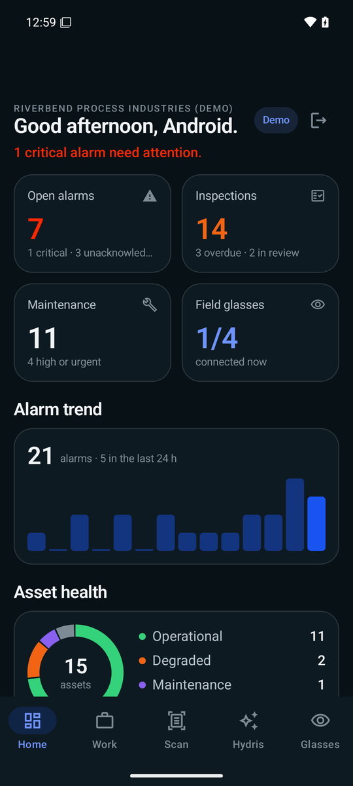
Figure 8. Home dashboard with KPI tiles, alarm trend and asset health
Data. GET /overview, refreshed every 15 s, plus the glasses link state from GlassesManager.state.
Layout, top to bottom.
- Header: organization name eyebrow, time-of-day greeting with the first name ("Good morning, Meera."), a "Demo" chip for demo organizations and a sign-out icon.
- Status line: "N critical alarms need attention." in Alert Orange, or "N open alarms, none critical.", or "All quiet on your sites."
- Four KPI tiles in two rows: Open alarms (critical and unacknowledged counts, orange when any are critical), Inspections (due, overdue, in review; amber when overdue), Maintenance (open, high or urgent), Field glasses (connected over registered across the organization, with "Ray-Ban Meta linked" when this phone's glasses are registered with DAT).
- Alarm trend: total for the last 14 days, count in the last 24 h, and a bar chart where the latest day is full Signal Blue.
- Asset health: donut of asset statuses (operational, degraded, down, maintenance, standby) with a legend.
- Live measurements: one card per metric with label, asset tag, freshness dot and age, "synthetic" when the source is the simulator, and the value with unit.
- Recent alarms: severity dot, title, state and age, severity chip; critical alarms get an orange card border.
- Activity: the last eight audit events with actor and age.
Table 7. Home interactions
Element | Action
Open alarms, Inspections, Maintenance tiles | Navigate to Work
Field glasses tile | Navigate to Glasses
Live measurement card | Open Sensor detail
Recent alarm card | Open Alarm detail
Sign-out icon | Stop voice, POST /auth/logout, clear cookies, return to Login

States. Loading (spinner) until the first overview arrives; error note if it fails with no cached value; content otherwise. A failed refresh keeps the last overview on screen and only shows an error when nothing has loaded yet.

5.3 Hydris assistant
Purpose. Ask questions about readings, alarms, work or an asset, by typing or by voice, and get answers grounded in live plant data.
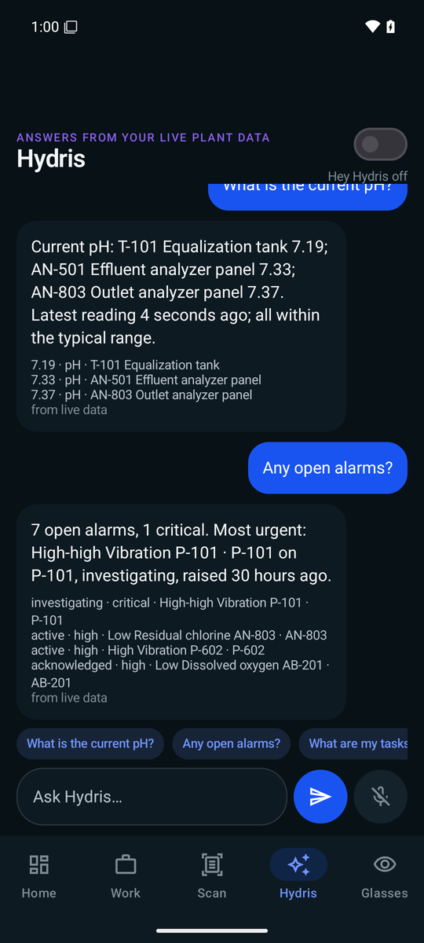
Figure 9. Hydris assistant answering with facts from live data
Layout. Eyebrow "Answers from your live plant data" in Insight Purple, a "Hey Hydris" switch with a status line ("Hey Hydris off", "listening · glasses mic", "listening · phone mic" or "starting…"), the conversation list, a row of suggestion chips ("What is the current pH?", "Any open alarms?", "What are my tasks?", "Dissolved oxygen", "Status of P-101"), a text field with a Send button and a Talk button.
Answers. POST /assistant/ask {text, history} with the last six turns. The answer bubble shows the text, up to four facts ("7.3 · Outlet pH"), and the engine label ("from live data" for the rules engine hydris-rules, otherwise the engine name). If the call fails, the bubble says "Sorry, I couldn't get that answer" with the error message.
Voice behaviour. The wake phrase regex is the same as WAKE_RE in packages/domain/src/voice.ts: "hey", "hi", "hay", "ok", "okay" or "a", followed by one of the common recognitions of "Hydris" ("hydris", "hydras", "hydrus", "hydrous", "high dris", "hi dris", "hydra", "idris"). A stop phrase ("stop", "cancel", "thanks", "thank you", "never mind", "that's all", "bye") ends the follow-up window. Answers are spoken only when Hey Hydris is on.
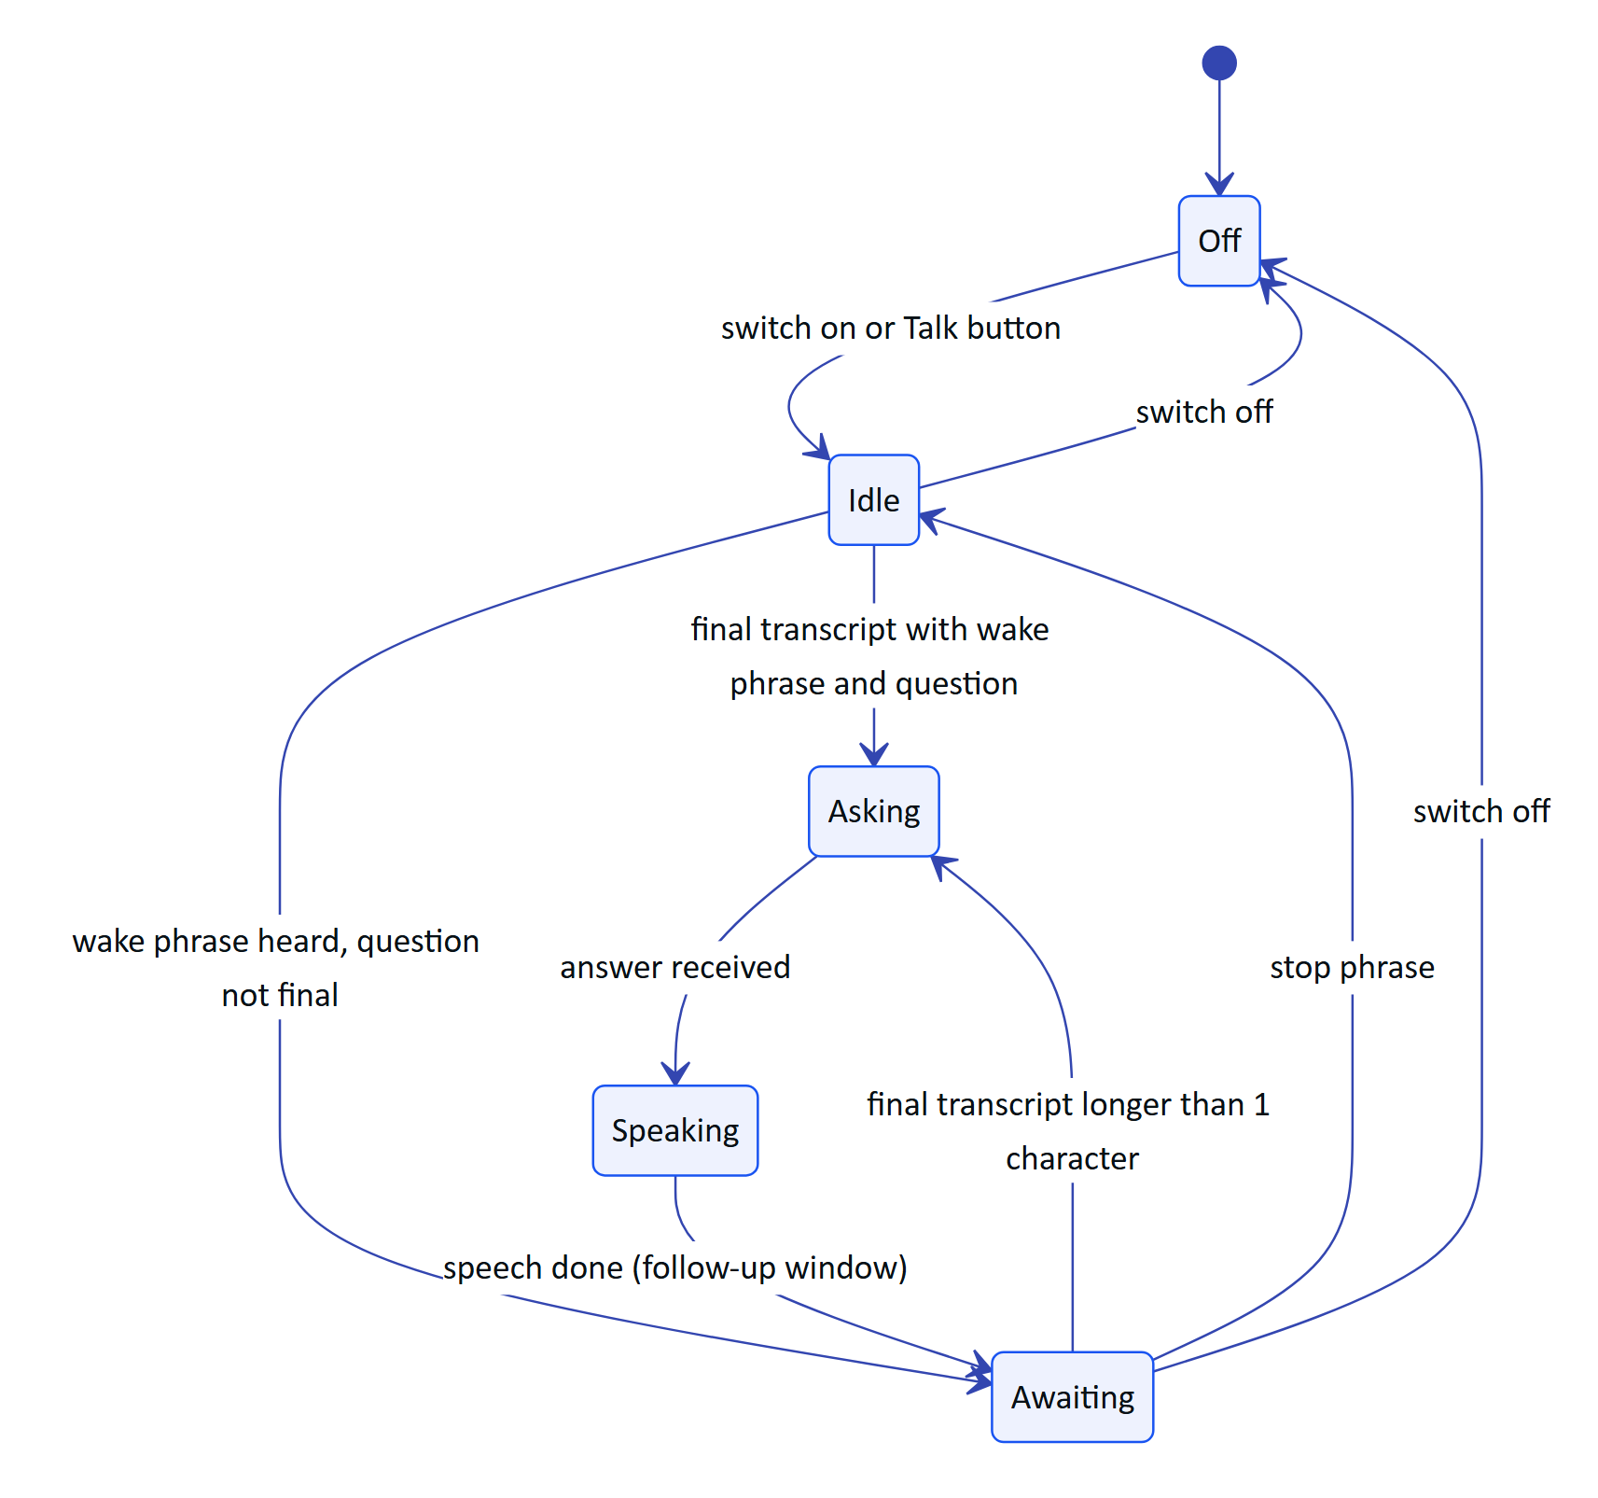
Figure 10. Wake-phrase state machine in AskScreen.kt
NOTE
The native app keeps the follow-up window open until a stop phrase or the switch is turned off. The glasses web viewport (apps/web/src/glasses/VoiceAssistant.tsx) closes it after 8 s of silence. Aligning the two (an 8 s timeout on the phone) is Planned.

5.4 Work
Purpose. Everything assigned or open, in five tabs: Alarms, Inspections, Maintenance, Sensors and Audit docs (PrimaryScrollableTabRow).
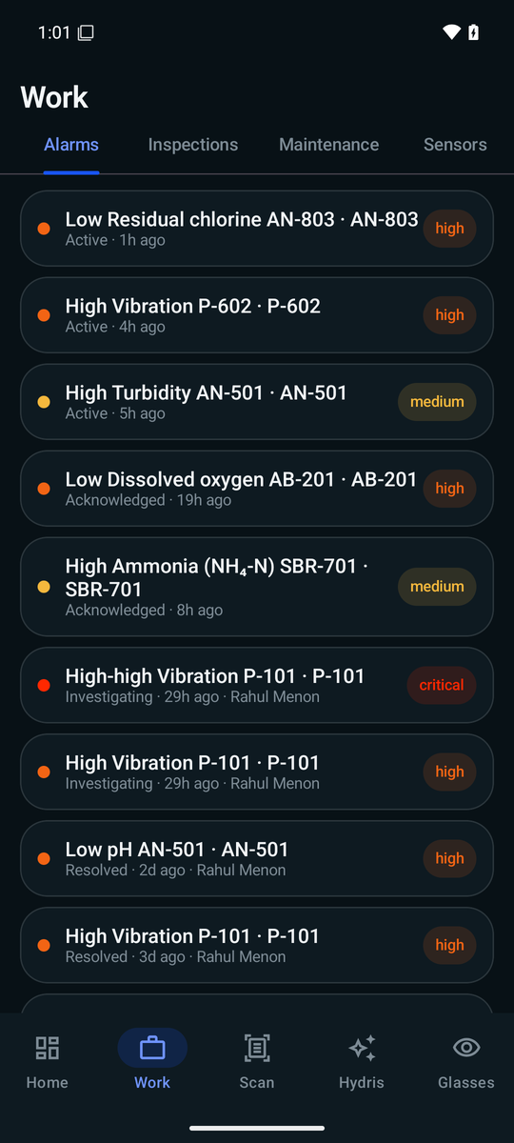
Figure 11. Work screen on the Alarms tab
Table 8. Work tabs
Tab | Data | Row content | Actions | Status
Alarms | GET /alarms, closed alarms hidden, 15 s refresh | Severity dot, title, state, age, assignee, severity chip; orange border when critical and active | Open Alarm detail | Built
Inspections | GET /inspections | Title, status chip, assignee, site, overdue marker, progress bar of answered over total steps | None (read-only) | Partial: running an inspection on the phone is Planned
Maintenance | GET /maintenance, completed and cancelled hidden | Title, priority chip, status, assignee, checks done; expands to description and checklist | Toggle checklist items (POST /maintenance/{id}/checklist/{itemId}) | Built; start, hold and complete are Planned
Sensors | GET /sensors, 10 s refresh | Name, freshness dot, tag, age, open alarm count, value in orange when alarmed | Open Sensor detail | Built
Audit docs | GET /audit-docs, 20 s refresh | Title, status chip, values, tables, capture route, author, age, review progress and engine agreement | None (review stays in the console) | Built

Empty states are explicit: "No open alarms.", "No inspections.", "No open maintenance tasks.", "No sensors.", and "No audit documents yet - scan one from the Scan tab."

5.5 Alarm detail
Purpose. Understand one alarm and move it through its lifecycle.
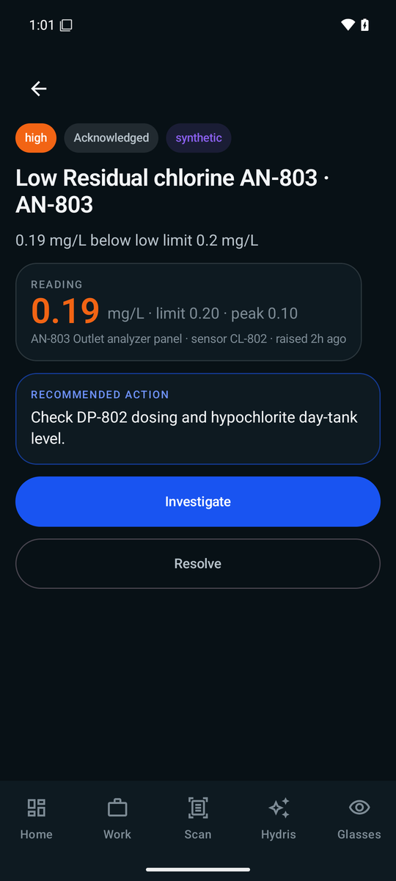
Figure 12. Alarm detail with reading, limit, recommended action and actions
Layout. Back button; severity chip (filled), state chip and "synthetic" chip for simulator alarms; title and description; a Reading card with the trigger value in the severity colour, unit, limit and peak, asset, sensor tag and age; a Recommended action card; then action buttons for the current state. The first action is a filled button, the second an outlined button.
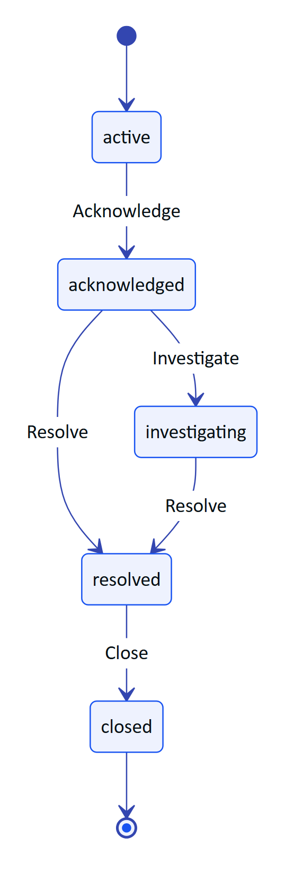
Figure 13. Alarm actions offered by state (AlarmDetailScreen)
Each button calls POST /alarms/{id}/{action} and reloads the alarm. Server rules still apply: if the user lacks the permission for an action, or another user already moved the alarm, the API error message is shown in an ErrorNote and the reloaded alarm shows the real state.
Planned on this screen: resolution notes (the repository already accepts a note), the alarm history timeline, the SOP link, assignment, and a "pending" marker for actions taken offline.

5.6 Sensor detail
Purpose. Trend of one sensor with its typical range.
Data. GET /telemetry/sensors/{id}/history?from=…&points=144 with from set to 6, 24 or 168 hours ago (filter chips "6 h", "24 h", "7 d"), refreshed every 15 s.
Layout. Tag and measurand label, sensor name, the last value in 44 sp, freshness and the number of readings, the range chips, a 220 dp line chart with a gradient fill, the typical range shaded in green when the API provides typicalRange, min, typical and max labels, and a "What this measures" card when the API returns an explanation.
Status. Built. Thresholds overlay, CSV export and pinch zoom are Planned.

5.7 Scan
The Scan tab is the app's most complex screen. Its pipeline is described in detail in the "Audit scan pipeline" chapter; this section covers the UI.
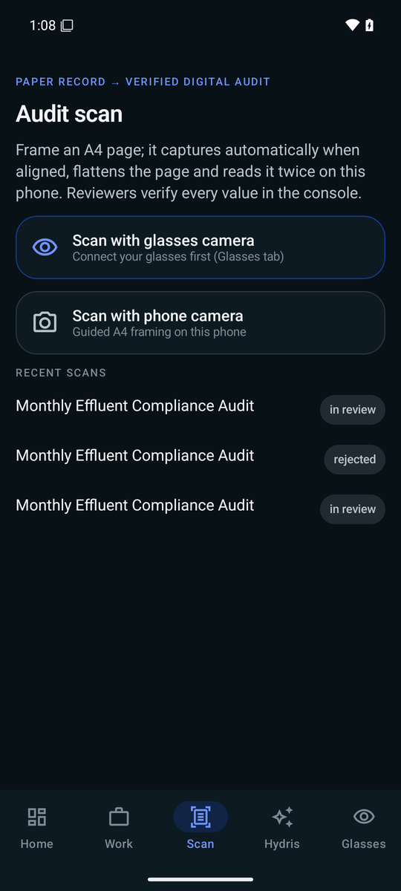
Figure 14. Scan menu with glasses, phone and import options
Menu. Eyebrow "Paper record → verified digital audit", title "Audit scan", explanation, and three source cards:
- Scan with glasses camera (Signal Blue border). Subtitle shows the glasses name and "or press the capture button" when DAT registration is complete, otherwise "Connect your glasses first (Glasses tab)".
- Scan with phone camera: guided A4 framing with CameraX. Asks for the camera permission in context.
- Import a photo: Android photo picker (PickVisualMedia, images only). Also the path on devices without a usable camera.
Below the cards, up to four recent scans with their status.
Guided capture. A status bar shows the guidance message with a coloured dot (green when ready, grey with no document, orange otherwise) and a source chip ("phone" or "Ray-Ban Meta"). The preview fills the remaining height with an A4 guide rectangle (86 % of the frame height), the detected page outline, corner dots and a green progress bar while the auto-capture timer runs. "Capture now" forces a capture; "Cancel" returns to the menu or to the review.
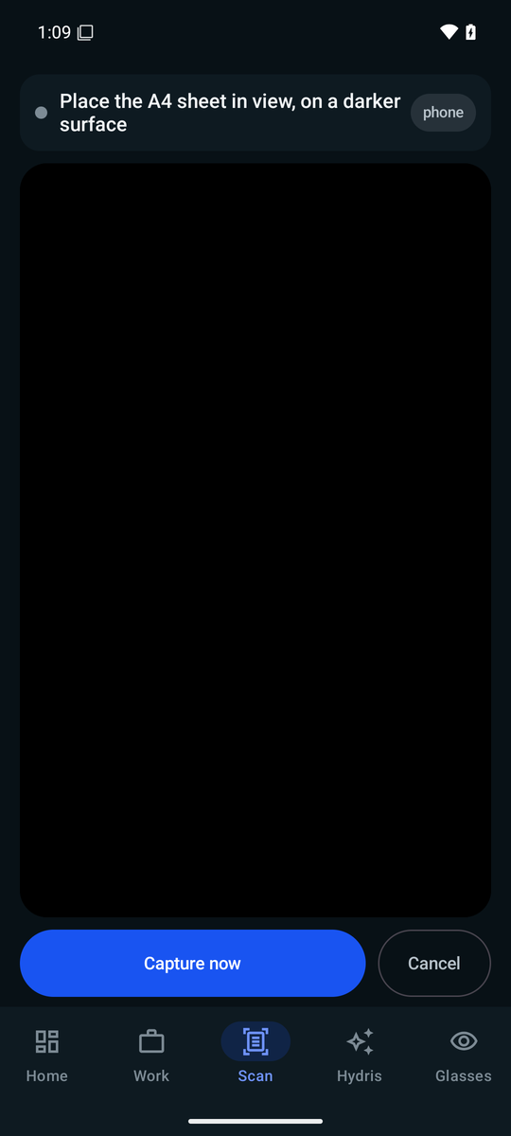
Figure 15. Guided capture waiting for an A4 sheet
Review. "N page(s) read on this phone", thumbnails of every page with the first pass's mean confidence, and a "Lines read (pass 1)" card with up to eight label and value pairs from the latest page. Buttons: "Send for verification", "Add page" (disabled at six pages) and "Discard".
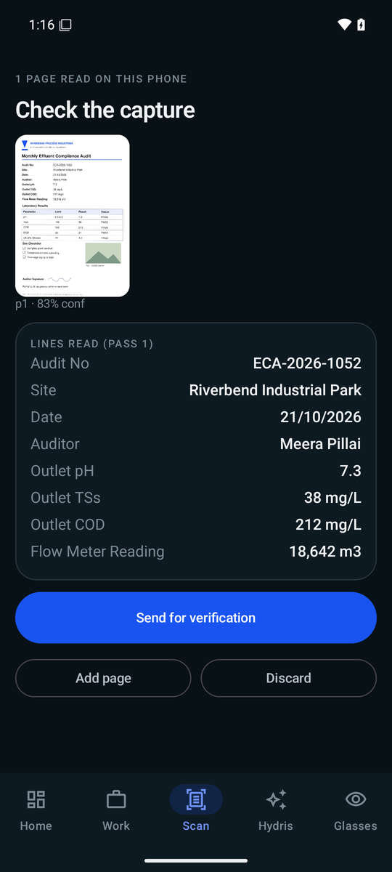
Figure 16. Review of a captured page with label and value pairs
Sent. Eyebrow "Sent · awaiting dual verification", the document title detected by the server, chips for values, tables, engine agreement and items to check, the capture route, and "Scan another document".
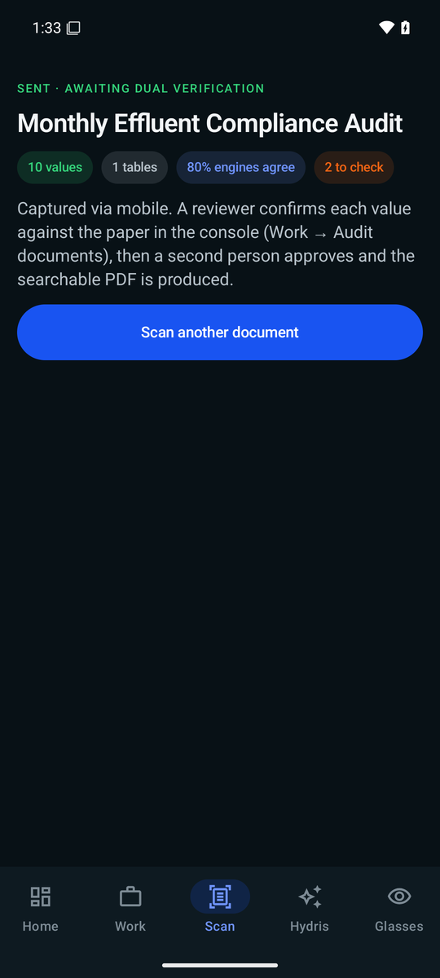
Figure 17. Scan sent for dual verification
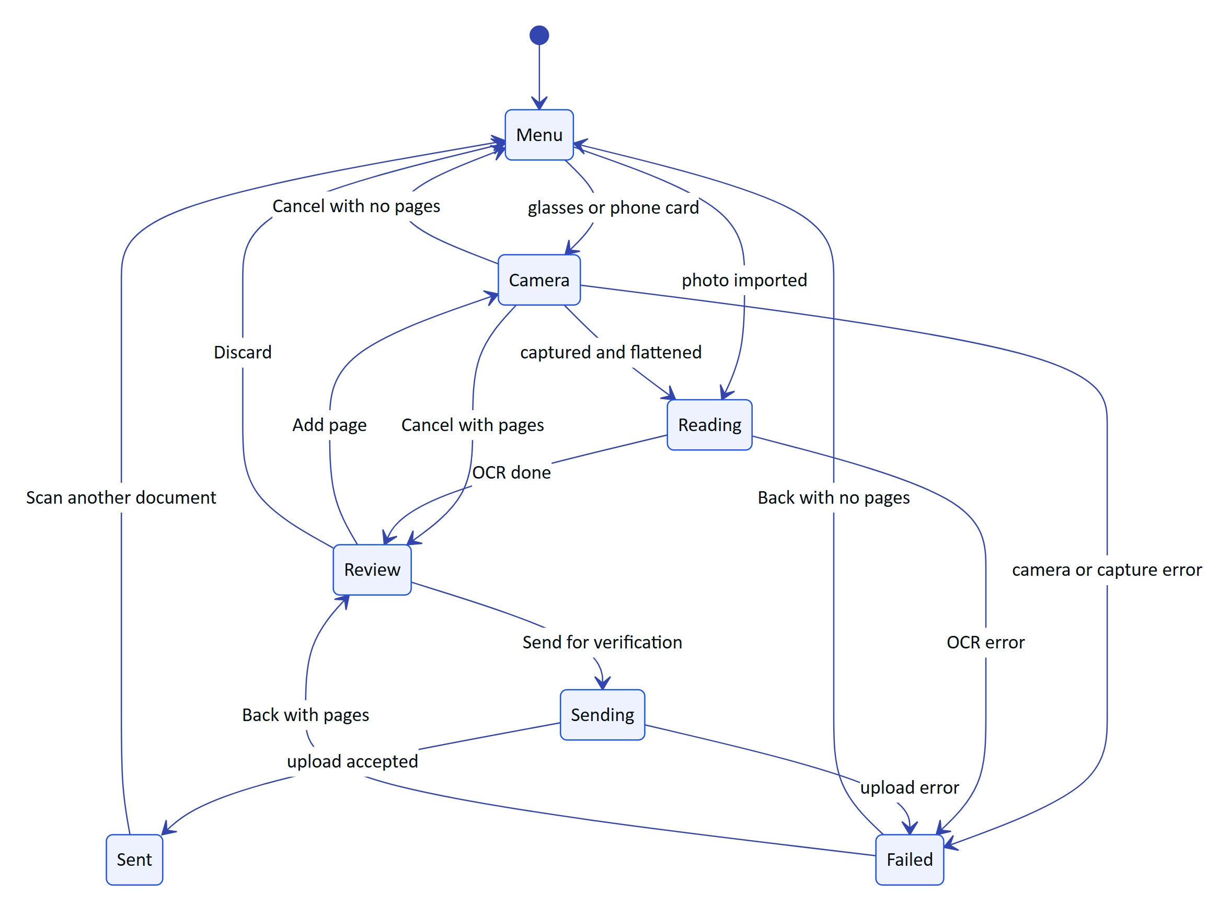
Figure 18. Scan screen stages (sealed interface Stage in ScanScreen.kt)
Capture button. While the menu or review is showing, a short press of the glasses capture button starts a glasses scan. During guided capture with the glasses source, it takes the photo.

5.8 Glasses
Purpose. One place to connect Ray-Ban Meta glasses, test them and register them with Hydris.
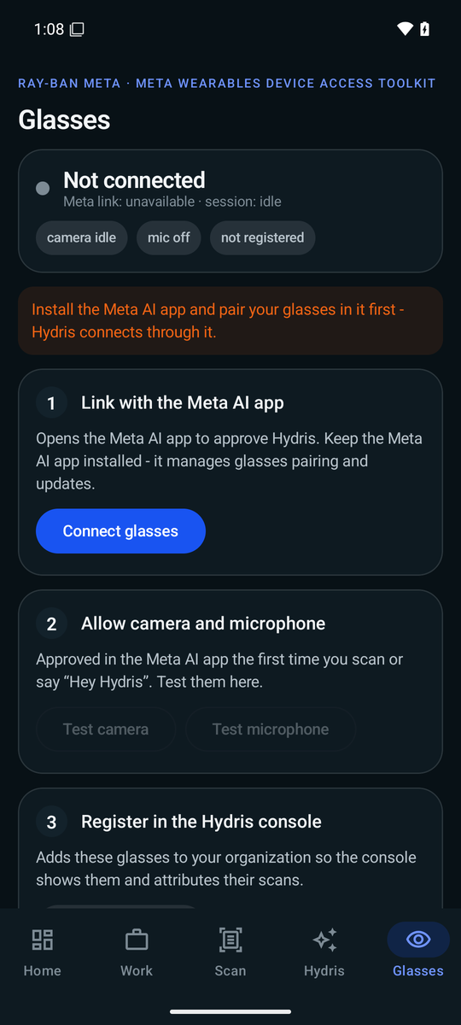
Figure 19. Glasses screen before the Meta AI app is installed
Status card. Glasses name (or "Waiting for glasses" or "Not connected"), status dot (green when registered and a device is visible, amber when registered with no device, grey otherwise), "Meta link" registration state and "session" state, and three chips: camera live or idle, mic state, and "in Hydris console" or "not registered".
Table 9. Glasses setup steps
Step | Done when | Action | Notes
1 Link with the Meta AI app | DAT registrationState is REGISTERED | "Connect glasses" initializes DAT if needed and calls startRegistration; "Disconnect" calls startUnregistration | Fails early with a clear message if the Meta AI app is missing
2 Allow camera and microphone | Camera streaming or speech listening | "Test camera" starts and stops a preview; "Test microphone" starts and stops speech | Each test triggers the Meta AI permission prompt the first time
3 Register in the Hydris console | A device refresh token is stored | "Register glasses" runs the pairing flow; "Unregister" logs the device out and forgets its tokens | Requires the device.pair permission on the server

Below the steps, a card lists what the glasses do in Hydris (audit scan, capture button, Hey Hydris, alarm notifications) and a "Connection log" card shows the latest eight of up to 30 DAT log lines kept in memory.
The DAT flows behind this screen are specified in the Glasses Integration document (HFG-GLS). The registration with Hydris is described under "Data layer and networking" below.

6 Data layer and networking

6.1 API client
HydrisApi talks to ${BuildConfig.HYDRIS_URL}/api. HYDRIS_URL comes from hydris_url in local.properties and defaults to https://hydrisview.vercel.app. Every request sends accept: application/json; JSON bodies use application/json; non-GET requests without a body send {}.
Table 10. HTTP client configuration
Setting | Value | Why
Connect timeout | 15 s | Fail fast on dead networks
Read timeout | 90 s | OCR uploads with server-side vision extraction can take a while
SSE read timeout | 0 (none) | The event stream is long-lived; the server sends heartbeats
JSON | ignoreUnknownKeys, explicitNulls = false, encodeDefaults | The API can add fields without breaking older app builds
Errors | ApiException(status, code, message) parsed from {error:{code,message}} | Screens show the server's message

6.2 Session model
The app follows the web session contract exactly, so the server needed no mobile-specific auth:
- A short-lived access token returned by /auth/login, /auth/demo and /auth/refresh is kept in memory only (@Volatile accessToken).
- A rotating refresh cookie (hg_refresh, path /api/auth) and, for demo accounts, the demo session cookie are stored by an OkHttp CookieJar whose backing store is the encrypted SecureStore entry cookies.
- The cookie jar only sends cookies to the configured host and drops expired cookies on load and on save.
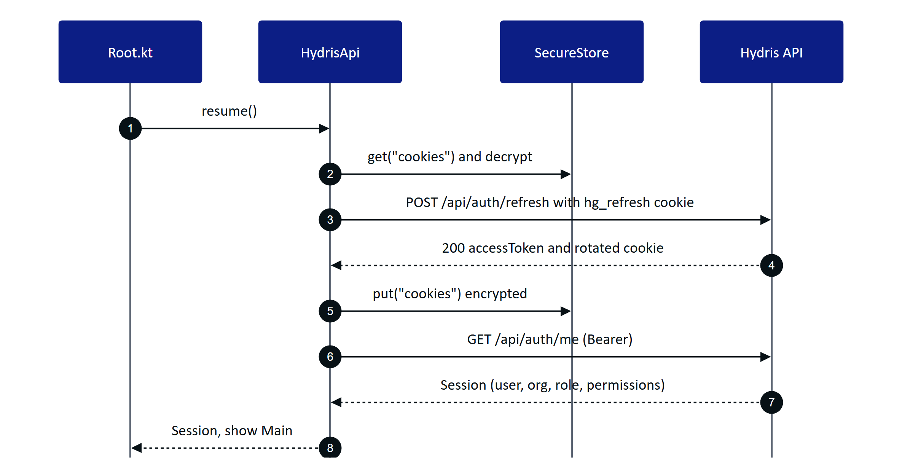
Figure 20. Session restore on app start

6.3 Refresh on 401 with a mutex
raw() retries a 401 once after a successful refresh, except for /auth/login and /auth/demo. refresh() is wrapped in a coroutine Mutex, so when several screens hit a 401 at the same moment the refresh calls run one after another and the server sees each rotated cookie in order. This matters because the API revokes the whole refresh family when a cookie is reused outside its grace window.
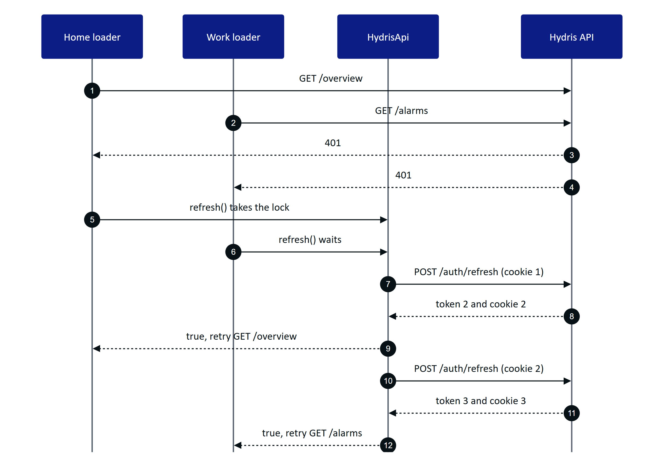
Figure 21. Parallel 401s share one refresh at a time
NOTE
The second waiter performs its own refresh rather than reusing the first result. That is correct but costs one extra rotation. A Planned improvement is to skip the refresh when the access token changed while waiting for the lock.

If the retry still returns 401, or the refresh fails, onSessionLost fires and the user returns to Login with "Session ended. Please sign in again."

6.4 Device credential channel
When the glasses are registered, a second credential set is stored in SecureStore: device.access, device.refresh, device.name. deviceCall() sends a request with the device access token and, on 401, exchanges the device refresh token at POST /device/refresh for a new pair and retries once. Scans captured with the glasses are uploaded through this channel so the console attributes them to the device (capturedVia set by the server from the principal), while every other call uses the user's token.
RISK
The device refresh in deviceCall() is not serialized by a mutex. Two concurrent glasses uploads could both rotate the device token and trigger reuse detection. Today only one upload runs at a time (the Scan screen is modal), so the risk is low; adding a lock is Planned.

6.5 Repository
Table 11. Repository functions and endpoints
Function | Method and path | Used by
overview() | GET /overview | Home
alarms() | GET /alarms | Work alarms tab
alarm(id) | GET /alarms/{id} | Alarm detail
alarmAction(id, action, note) | POST /alarms/{id}/{action} | Alarm detail
inspections() | GET /inspections | Work inspections tab
tasks() | GET /maintenance | Work maintenance tab
toggleChecklist(task, item, done) | POST /maintenance/{id}/checklist/{itemId} | Work maintenance tab
sensors() | GET /sensors | Work sensors tab
history(id, hours) | GET /telemetry/sensors/{id}/history | Sensor detail
notifications() | GET /notifications | Not used by a screen yet
ask(text, history) | POST /assistant/ask | Hydris assistant
auditDocs() | GET /audit-docs | Work audit docs tab, Scan menu
uploadScan(upload, viaGlasses) | POST /audit-docs, then POST /audit-docs/{id}/enhance when aiStatus is pending | Scan
registerGlasses(hw, name, model) | POST /pairing/challenges, GET /pairing/lookup, POST /pairing/approve, POST /pairing/challenges/{id}/poll | Glasses
unregisterGlasses() | POST /device/logout (device token) | Glasses

6.6 Registering glasses as a Hydris device
The console already pairs display glasses with an RFC 8628-style device authorization flow: the device asks for a challenge and shows a code, a signed-in user approves the code on /pair, and the device polls until it receives tokens. The phone plays both roles in one go: it creates the challenge for the glasses and immediately approves it as the signed-in user.
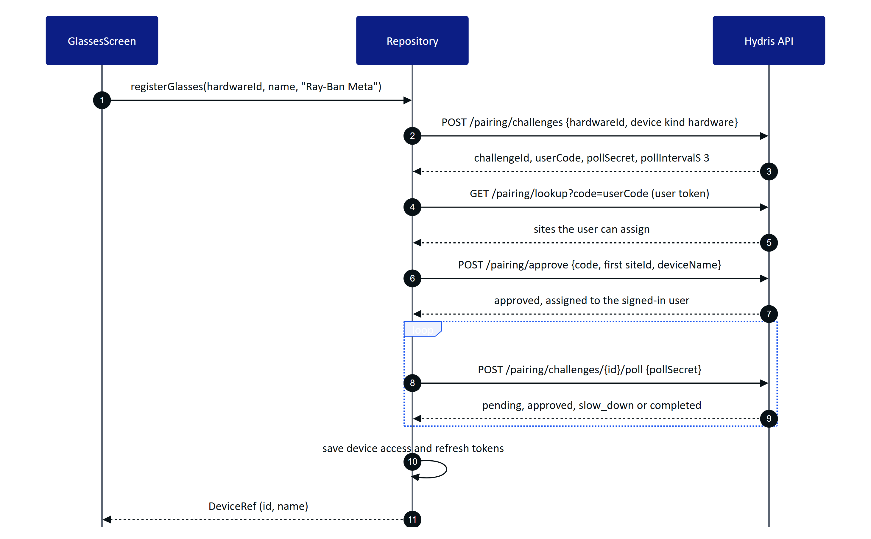
Figure 22. Self-approved registration of the glasses (Repository.registerGlasses)
Rules enforced by the server (apps/api/src/modules/devices.ts): the approver needs device.pair; pairing to another user needs device.manage; glasses registered to another organization must be revoked there first (device_owned_elsewhere); challenges expire after 300 s; polling faster than every 3 s returns slow_down. The hardware ID is rbm- followed by the first 16 bytes (hex) of SHA-256 over hydris-glasses: plus the DAT device identifier, so the raw Meta identifier never leaves the phone and re-registering the same glasses reuses the console's device record.
WARNING
The app assigns the glasses to the first site returned by /pairing/lookup. Users with access to several sites cannot choose. A site picker is Planned before multi-site pilots.

6.7 Realtime events (SSE)
HydrisApi.events() returns a cold Flow<Pair<event, data>> backed by a daemon thread. It connects to GET /api/events/stream with the bearer token and accept: text/event-stream, and sends last-event-id after the first event so the server can replay missed events. The parser handles event:, data: and id: lines and emits on each blank line.
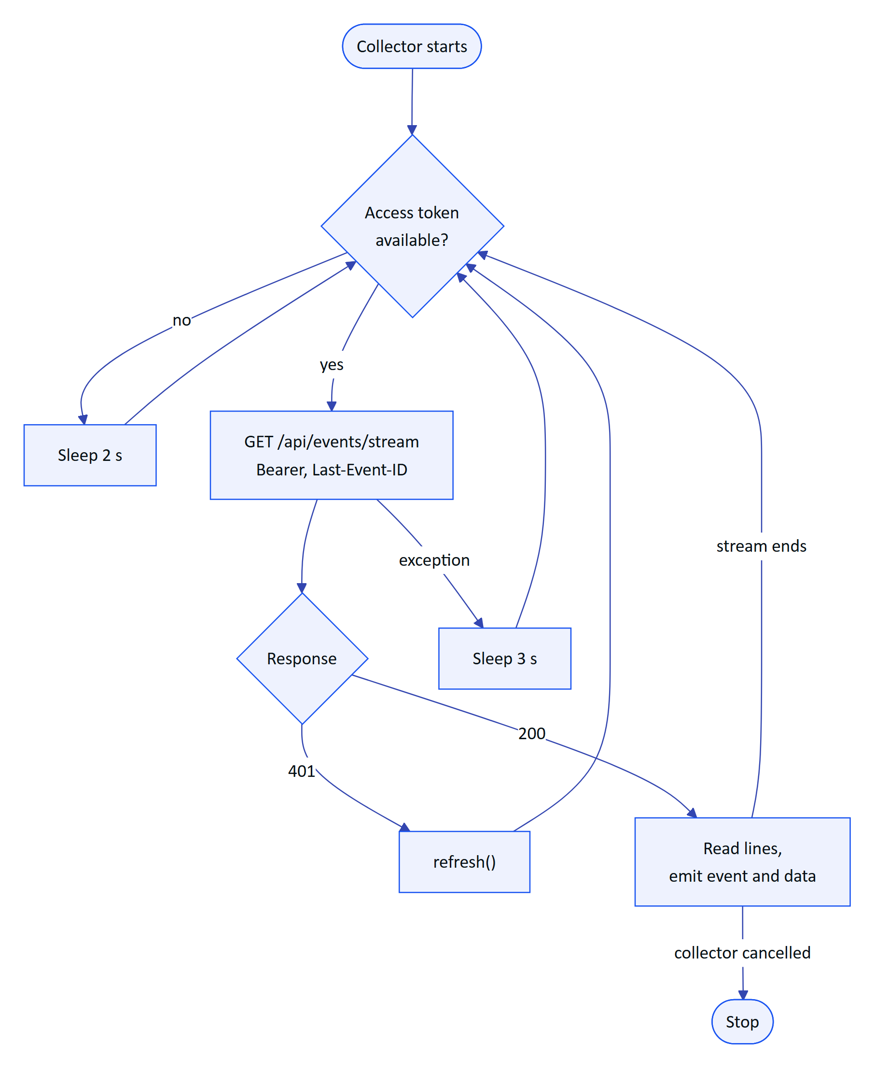
Figure 23. SSE connection loop in HydrisApi.events()
The server (apps/api/src/modules/realtime.ts) sends a ready event with retry: 3000, comment heartbeats every 15 s, and ends long-lived streams cleanly so clients reconnect with Last-Event-ID.

7 Audit scan pipeline

7.1 End-to-end flow
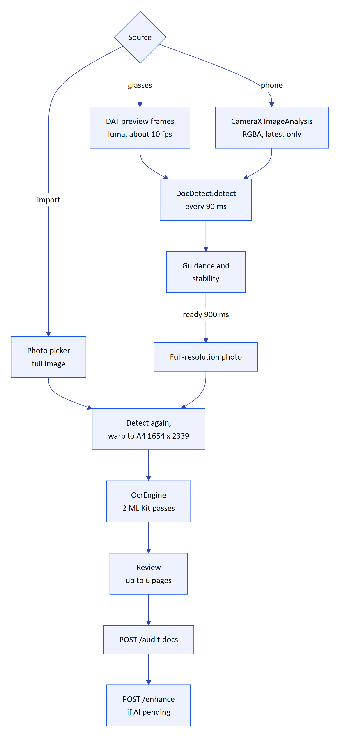
Figure 24. Audit scan pipeline on the phone

7.2 Page detection (DocDetect)
scan/DocDetect.kt is a line-by-line Kotlin port of apps/web/src/lib/docdetect.ts with the same thresholds, so the phone, the glasses web viewport and the console guide the wearer identically.
Table 12. Detection algorithm
Step | What it does | Constant
Downscale | Scale the frame to 200 px wide, keep aspect | DW = 200
Grayscale | Luma with integer weights 299, 587, 114 per 1000
Threshold | Otsu's threshold on the histogram, floored | at least 90
Region | 4-connected flood fill of bright pixels; keep the largest region | Region must cover at least 6 % of pixels
Corners | Extremes of x+y (top-left, bottom-right) and x−y (top-right, bottom-left)
Coverage | Quad area over frame area
Aspect | Longer over shorter mean side | A4 is √2 (1.414)
Skew | Largest deviation of a corner angle from 90°
Tilt | Angle of the top edge
Edge contact | Region pixels on the frame border over the perimeter | More than 8 % means cut off
Sharpness | Variance of the Laplacian inside the quad's bounding box

7.3 Guidance
DocDetect.guide() checks conditions in a fixed order and returns the first message that applies. The order matters: there is no point asking the wearer to straighten a page that is half out of frame.
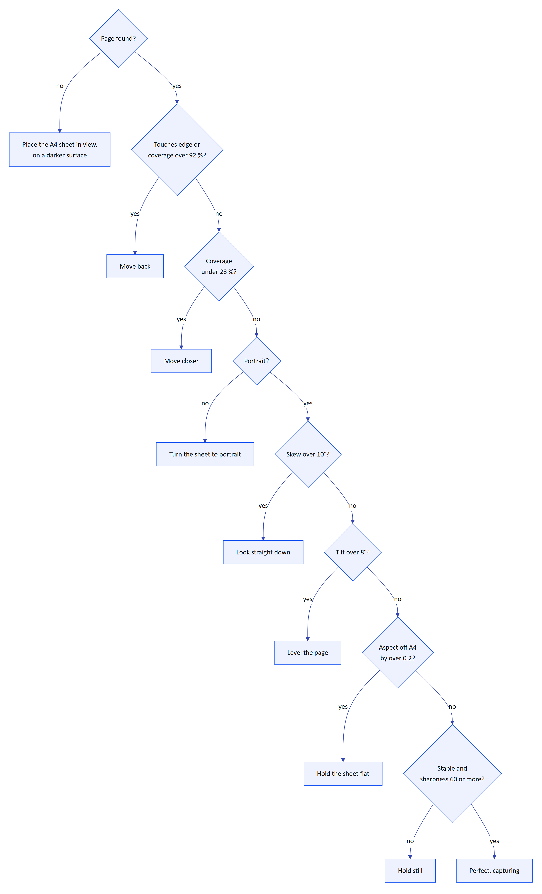
Figure 25. Guidance decision order (DocDetect.guide)

7.4 Stability and auto-capture
GuidedCapture runs detection at most every 90 ms. A frame is "still" when every corner moved less than 0.012 of the frame size since the previous detection (DocDetect.motion). Four still detections in a row make the page stable. When the guidance is "Ready", a timer starts; after 900 ms of continuous readiness the app captures automatically. Any non-ready frame resets the timer. The green progress bar shows the timer.

7.5 Capture and flattening
On capture the app takes a full-resolution photo: CameraX ImageCapture in CAPTURE_MODE_MAXIMIZE_QUALITY (rotated by the reported rotation degrees), or GlassesManager.capturePhoto() for the glasses (EXIF orientation applied). Detection runs again on the full photo. If it finds a page with coverage over 20 % that does not touch the edges, that quad is used; otherwise the last quad from the preview is used; if there is none, the photo is kept as is.
warpToA4 maps the unit square onto the quad with a projective homography (squareToQuad), insets the quad by 0.4 % to drop the page border, and samples the source bilinearly into a 1654 x 2339 bitmap: A4 at 200 dpi. Pixels outside the source are white.
NOTE
A comment in apps/web/src/lib/docdetect.ts still mentions 1240 x 1754 at 150 dpi, but the code in both the web and Android versions defaults to outW = 1654. The comment is stale.

7.6 On-device OCR (OcrEngine)
scan/OcrEngine.kt reads each page twice with ML Kit Text Recognition on the device. No image leaves the phone until the user taps "Send for verification".
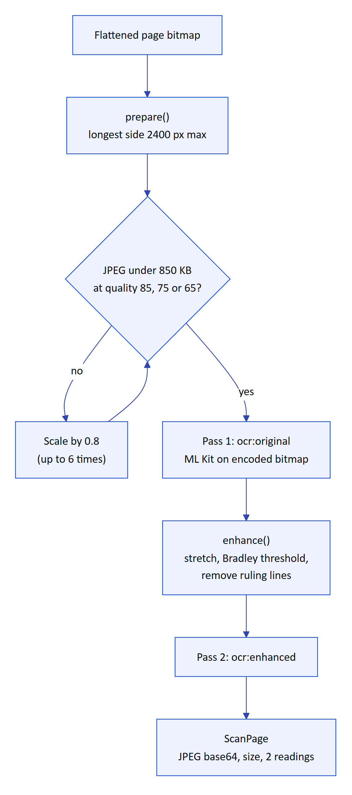
Figure 26. Two-pass OCR and upload sizing in OcrEngine.scan
Table 13. OCR details
Item | Behaviour
Size budget | Longest side at most 2400 px; JPEG at quality 85, then 75, then 65; if still over 850 KB, scale by 0.8 and retry, up to six times, else fail with "This image is too large to upload"
Pass 1 | ocr:original: the encoded bitmap as captured
Pass 2 | ocr:enhanced: grayscale, 1 % contrast stretch at both ends, Bradley adaptive threshold (window radius max(8, min(W,H)/32), factor 0.85), then removal of horizontal black runs of at least 20 % of the width and vertical runs of at least 2.8 % of the height, so table borders and underlines do not merge cells
Output format | OcrReading{engine, text, conf, lines[]} with words; boxes normalized to [x, y, w, h] in 0..1; confidences scaled to 0..100 to match the Tesseract-compatible web format in apps/web/src/lib/ocr.ts
Line order | Sorted by top edge, then left edge
Progress | "Preparing image" 5 %, "Reading text (pass 1 of 2)" 15 %, "Reading text (pass 2 of 2)" 55 %, "Done" 100 %

The two readings are the machine half of Hydris's dual verification: the server compares them field by field (agreement) and flags disagreements for the reviewer.

7.7 Label and value pairing on the review card
ML Kit often returns a form's label column and value column as separate lines. labelValues() takes every line that contains a colon. If text follows the colon, that is the value. Otherwise it looks for the nearest line to the right (starting beyond 90 % of the label's width) whose vertical centre is within 60 % of the label's height, and uses it as the value. The card shows the first eight pairs. This is display only; the server does its own structuring.

7.8 Upload limits
Table 14. Upload limits (apps/api/src/modules/audit-docs.ts and OcrEngine.kt)
Limit | Server | App
Pages per document | 6 (MAX_PAGES) | "Add page" disabled at 6
Bytes per page image | 900 KB (MAX_PAGE_BYTES) | Encodes under 850 KB to leave headroom
Request body | 8 MB | 6 pages of up to 850 KB in base64 fit
Image types | JPEG or PNG, checked by magic bytes | Always JPEG
Source tag | source field | "mobile"

After a successful upload, if the server reports aiStatus = "pending", the app calls POST /audit-docs/{id}/enhance to start the optional vision extraction. Failures of that call are ignored; the document is already saved.

8 Voice

8.1 Speech sources
voice/VoiceEngine.kt provides one transcript stream to the assistant regardless of where the audio comes from.
Table 15. Speech engines
Source | Recognition | Restart behaviour | Self-hearing protection
Glasses | DAT Speech capability on the glasses microphone; partial and final transcripts | GlassesManager restarts the speech capability when it reports STOPPED after having started, while listening is wanted | Transcripts are dropped while TTS is speaking
Phone | Android SpeechRecognizer, free-form model, partial results on, device locale | Restarts 150 ms after results, no match or speech timeout; 1200 ms after other errors | Recognizer is cancelled during TTS and restarted after
None | Not available | Not applicable | Not applicable

8.2 Speech output
Answers are spoken with Android TextToSpeech in the device locale, QUEUE_FLUSH, with a 30 s safety timeout. When the glasses are the active Bluetooth audio output, Android routes the speech to their open-ear speakers; the app does not route audio itself. speak() waits up to 1.5 s for the TTS engine to initialize the first time.
NOTE
The phone microphone needs RECORD_AUDIO, which the assistant requests when Hey Hydris is turned on. The glasses microphone needs the DAT MICROPHONE permission, approved in the Meta AI app.

8.3 Language
Recognition and speech use Locale.getDefault(). The assistant's answers come from the server in English. Hindi and other Indian languages for questions and answers are Planned and depend on server-side support in voice-assistant.ts.

9 Notifications
Built. HydrisApp creates a notification channel alarms ("Plant alarms", importance high, description "Critical and high alarms on your sites"). While the signed-in UI is composed, Root.kt collects the SSE stream and, for every alarm.created event whose state is active and whose severity is critical or high, posts a notification titled "Critical alarm" or "High alarm" with the alarm title, using the Hydris mark as the small icon and auto-cancel on tap.
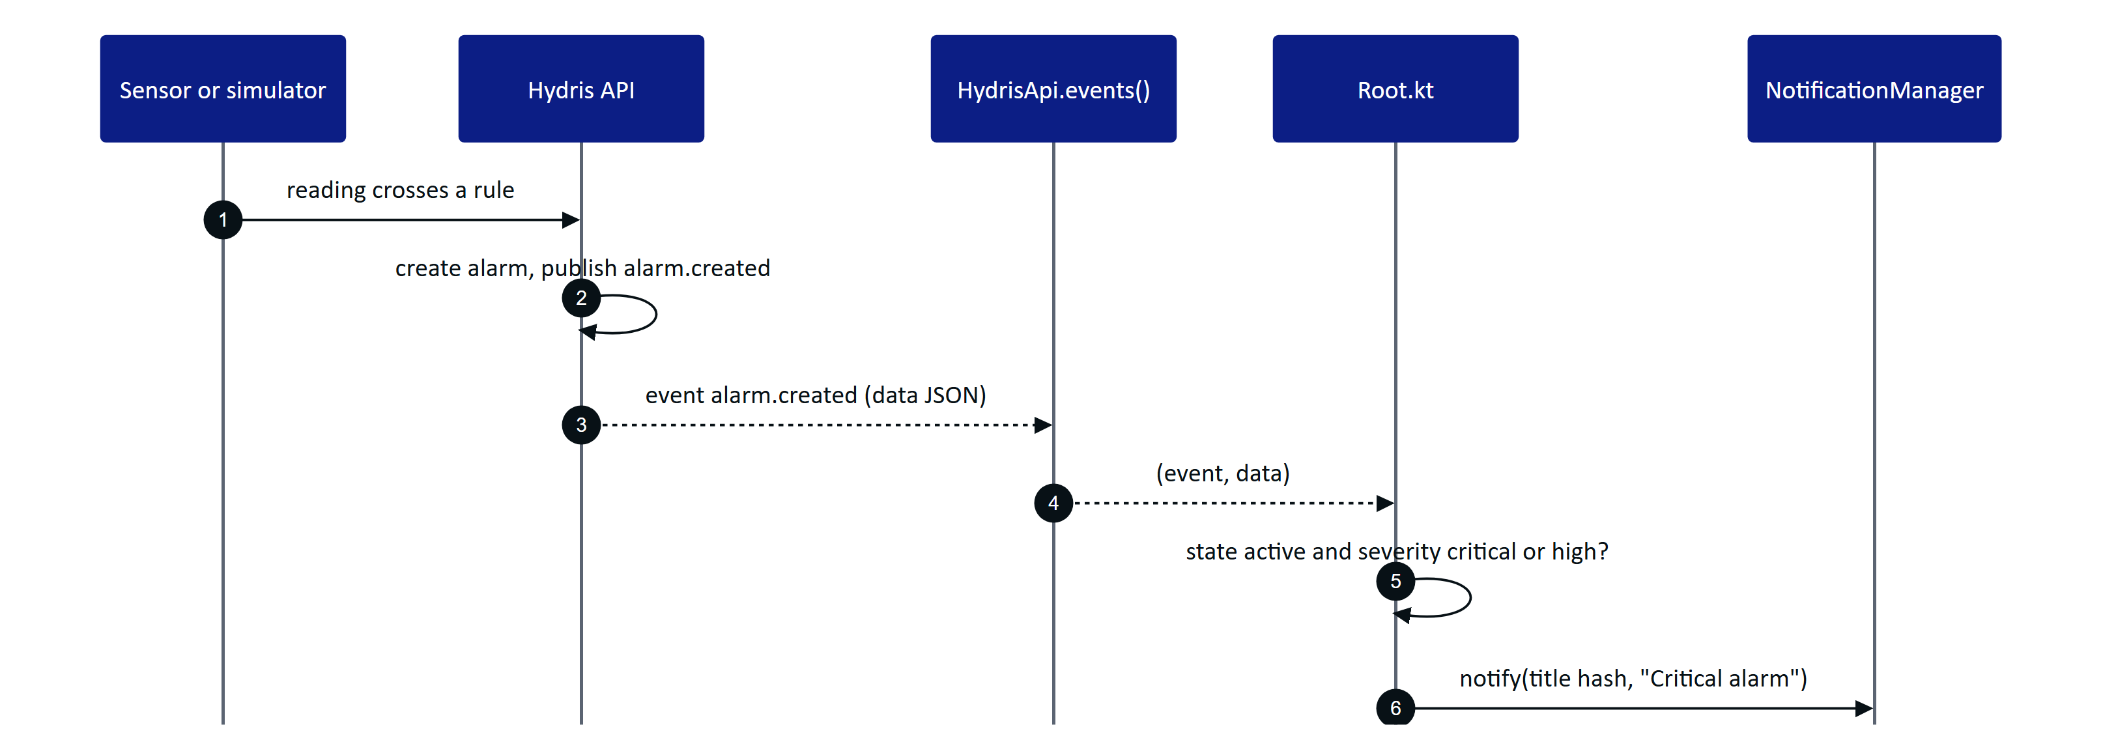
Figure 27. Alarm notification path
Table 16. Notification gaps
Gap | Effect | Plan
No push service | Notifications arrive only while the app process and signed-in UI are alive | FCM with a server-side sender (Planned)
Notification ID is the title's hash | Two alarms with the same title replace each other | Use the alarm ID (Planned)
Tap opens the app, not the alarm | Operator must find the alarm | Deep link alarm/{id} in the pending intent (Planned)
Permission asked on every start | Users who deny it are asked again on each onStart | Ask once, explain in Settings (Planned)
GET /notifications not shown | The in-app inbox is console only | Notifications screen (Planned)

10 Permissions

10.1 Permission matrix
Table 17. Android and DAT permissions
Permission | Kind | Declared in | Requested when | Used for | If denied
BLUETOOTH | Normal (install time) | Manifest | Always granted | DAT link | Not applicable
BLUETOOTH_CONNECT | Runtime (Android 12+) | Manifest | Every MainActivity.onStart, with the other two | DAT reaches the glasses through the Meta AI app | DAT is not initialized; glasses features unavailable, phone features work
POST_NOTIFICATIONS | Runtime (Android 13+) | Manifest | Every onStart | Alarm notifications | No notifications
INTERNET | Normal | Manifest | Always granted | API and SSE | Not applicable
CAMERA | Runtime | Manifest | Tapping "Scan with phone camera" | CameraX scan | "Camera permission is needed to scan with the phone"; import still works
RECORD_AUDIO | Runtime | Manifest | Turning Hey Hydris on | Phone microphone | Switch turns back off; typing still works
DAT CAMERA | Glasses capability | DAT | First glasses preview or photo | Glasses camera | "Camera permission denied in Meta AI"
DAT MICROPHONE | Glasses capability | DAT | First glasses speech start | Glasses microphone | "Microphone permission denied in Meta AI"; falls back to phone microphone

The manifest marks android.hardware.camera as not required, so the app installs on devices without a camera.

10.2 Glasses permission round trip
MainActivity registers Wearables.RequestPermissionContract() and exposes requestGlassesPermission(permission) as a suspend function guarded by a Mutex, so only one Meta AI prompt is open at a time. GlassesManager.ensurePermission() first calls Wearables.checkPermissionStatus() and only launches the prompt when the permission is not granted. The full sequence is in the Glasses Integration document.

11 Design system

11.1 Colour tokens
The Hx object in ui/theme/Theme.kt holds the brand palette shared with the website, console and glasses HUD. The app is dark only.
Table 18. Hx colour tokens
Token | Hex | Use
Hx.Midnight (Deep Midnight) | #081116 | App and window background, status bar
Hx.Surface | #0E1A21 | Cards, navigation bar, text fields
Hx.Surface2 | #13222B | Raised surfaces, step numbers, Talk button
Hx.Line | white at 12 % alpha | Card borders, dividers, chart grid
Hx.Signal (Signal Blue) | #1954F1 | Primary buttons, chart lines, progress
Hx.Core (Core Blue) | #1746E4 | Primary container
Hx.SignalText | #6F93FF | Blue text and icons on dark, selected tab
Hx.Alert (Alert Orange) | #FF2800 | Critical severity, errors
Hx.High | #F26414 | High severity, stale data, warnings
Hx.Medium | #F5B83D | Medium severity, delayed data
Hx.Ok (Active Green) | #00FE21 | Ready states, done steps (on dark only)
Hx.OkSoft | #34D27A | Live data, success chips, checklist done
Hx.Insight (Insight Purple) | #8A60F0 | AI surfaces, synthetic markers, maintenance health
Hx.Text | #F2F5F7 | Primary text
Hx.Text2 | #B7C2CA | Secondary text
Hx.Muted | #7D8B95 | Captions, inactive icons

Table 19. Semantic colour mappings
Mapping | Values
Hx.severity() | critical: Alert, high: High, medium: Medium, anything else: SignalText
Hx.freshness() | live: OkSoft, delayed: Medium, stale: High, anything else: Muted
Asset health (Home) | operational: OkSoft, degraded: High, down: Alert, maintenance: Insight, standby: Muted
Audit doc status | approved: OkSoft, rejected: Alert, verified: SignalText, others: Medium

11.2 Typography, shape and spacing
Table 20. Type scale (Material 3 Typography overrides)
Style | Size | Weight | Use
displaySmall | 34 sp | SemiBold | "Sign in"
headlineSmall | 24 sp | SemiBold | Screen titles
titleLarge | 20 sp | SemiBold | Section titles
titleMedium | 16 sp | Medium | Card titles
bodyLarge | 16 sp | Regular | Long text
bodyMedium | 14 sp | Regular | Body
bodySmall | 12.5 sp | Regular | Captions
labelSmall | 11 sp | Medium, 1.4 sp tracking | Uppercase eyebrows

Cards use a 22 dp corner radius and a 1 dp border; chips are fully rounded; text fields use 16 dp corners; primary buttons are 52 to 54 dp tall. KPI numbers are 34 sp. The app uses the system font; bundling Outfit to match the web is Planned.

11.3 Components
Table 21. Shared components (ui/components/Components.kt)
Component | Purpose
HCard | Rounded card with optional accent border and click
Eyebrow | Uppercase small label
SectionTitle | Section heading with optional action link
Chip | Rounded label, tinted or filled
Dot | Status dot
KpiTile | Label, large value, sub line, optional icon
ProgressBar | 6 dp rounded bar
Loading, ErrorNote | Standard loading and error states
Sparkline, LineChart, Bars, Donut | Canvas charts with no chart library
ago(), fmt(), label() | Relative time, number and label formatting

12 Accessibility
Field use means gloves, glare, noise and one free hand. The requirements below are written against that context.
Table 22. Accessibility requirements
Requirement | Status | Notes
Text scales with the system font size | Built | All text uses sp
Primary actions at least 48 dp tall | Built | Buttons are 52 to 54 dp; tabs use Material defaults
Touch targets of 56 dp for gloved use on primary flows | Partial | Main buttons meet it; chips, checklist rows and the sign-out icon do not
Content descriptions on actionable icons | Partial | Back, Sign out, Send and Talk have labels; source cards rely on their text
Colour is never the only signal | Partial | Severity has text chips; freshness also has text; scan guidance has text; the alarm card border is colour only
Contrast on Deep Midnight | Built for text | Hx.Text and Hx.Text2 are high contrast; Hx.Muted captions should be checked at 4.5:1
Voice alternative for the main question flow | Built | Hey Hydris and Talk button
Screen reader pass (TalkBack) | Planned | Not yet audited
Reduced motion | Not applicable | The app uses no decorative animation
Light theme for office use | Planned | Dark only today

13 Performance budgets
IMPORTANT
The numbers below are targets for pilot acceptance. None has been measured yet on reference hardware. QA will record results in the QA test plan (HFG-QA) on a mid-range reference phone.

Table 23. Performance targets
Metric | Target | Notes
Cold start to Home with a valid session | Under 2.0 s | Includes refresh and /auth/me
Home overview refresh | Under 800 ms on 4G | One request every 15 s
SSE alarm to notification | Under 2 s after the server publishes | Foreground process
Detection per preview frame | Under 25 ms | 200 px frame on the main thread; moving it off the main thread is Planned
Warp to A4 | Under 1.5 s | 3.9 MP output with bilinear sampling in Kotlin
OCR, two passes, one A4 page | Under 6 s | ML Kit on device
Upload, one page | Under 900 KB | Enforced by OcrEngine
Peak memory during a six-page scan | Under 300 MB | Pages are kept as full bitmaps for thumbnails; downsampling thumbnails is Planned
Glasses camera on | Only while the scan camera is open | See the battery gap below
APK size (release, minified) | Under 45 MB | ML Kit bundled model and DAT included

RISK
Battery: GlassesManager.stopPreview() stops forwarding frames but does not stop the DAT camera stream; the stream ends only when the session stops. On hardware this may keep the glasses camera and LED on after leaving the scan screen. Stopping the stream on stopPreview is a Planned fix that must be verified on real glasses.

14 Offline behaviour and sync

14.1 Today
Table 24. Offline behaviour as built
Situation | Behaviour
Network lost on a loaded screen | The last loaded data stays on screen; the next refresh fails silently because error is only shown when nothing has loaded
Network lost on a new screen | Loading spinner, then the error message
App restarted offline | Session restore fails and the user sees Login (the cookie is kept, so sign-in works once online again after restart)
Alarm action offline | Fails with the network error; nothing is queued
Checklist toggle offline | Fails silently (runCatching), the list reloads and shows the real state
Scan offline | Capture and OCR work fully offline; upload fails and the pages stay in the review until the user retries or discards, but are lost if the app process ends
Voice offline | Phone recognition may still work (device dependent); the answer fails with an error bubble

14.2 Planned
- Room cache of assigned inspections with step snapshots, tasks, sensor last values and the device context, with "last updated" shown on every cached screen.
- Outbox for inspection responses (with clientOpId, made idempotent by the server's unique index), checklist toggles, alarm acknowledgements, notes and scans (pages written to app-private storage until accepted).
- WorkManager replay with exponential backoff when connectivity returns. Conflicts (409, invalid transition) shown as "updated by someone else"; local edits never silently dropped. Offline alarm acknowledgements shown as "pending" until confirmed.
- The glasses web viewport already implements the inspection response queue (apps/web/src/glasses/link.ts, flush()), which is the reference behaviour for the native outbox.

15 Security
Table 25. Security controls
Control | Status | Detail
Access tokens in memory only | Built | HydrisApi.accessToken, never persisted
Refresh cookies and device tokens encrypted at rest | Built | SecureStore: AES-256-GCM, non-exportable Android Keystore key alias hydris.secure.v1, random 12-byte IV stored before the ciphertext, 128-bit tag; only ciphertext in SharedPreferences hydris.secure
Undecryptable values treated as absent | Built | get() returns null if decryption fails (for example after a key reset), which forces a new sign-in
Backups disabled | Built | android:allowBackup="false"
HTTPS only | Built by default | No usesCleartextTraffic; the default for target SDK 28 and later blocks cleartext
Cookies scoped to the Hydris host | Built | Cookie jar ignores other hosts
Raw glasses identifier not sent | Built | SHA-256 derived rbm- hardware ID
Images kept in memory, never written to the gallery | Built | Pages are bitmaps in the Scan screen state
Sign out revokes the server session | Built | POST /auth/logout, then local cookies cleared
FLAG_SECURE on scan review | Planned | Prevents screenshots and recents thumbnails of documents
Certificate pinning with a backup pin | Planned | For production hosts
Release signing key | Planned | Release builds are currently signed with the debug key
Biometric re-entry after long inactivity | Planned
Managed configuration (MDM) for server URL | Planned | app_restrictions.xml
Device integrity signals | Planned | Informational only for pilots

CAUTION
Until the release signing configuration is replaced, any build produced with assembleRelease is signed with a debug key and must not be distributed outside the team.

The Hydris-wide threat model, data classification and retention are in the Security and Privacy document (HFG-SEC).

16 Build and release

16.1 Project setup
Table 26. Gradle setup
Item | Value
Root project | hydris-field, one module :app
Namespace and application ID | ai.hydris.field
Version | versionName 1.0.0, versionCode 1
Repositories | Google (Android and Google groups only), Maven Central, Gradle Plugin Portal; FAIL_ON_PROJECT_REPOS
Gradle JVM | -Xmx4g
Java and Kotlin target | 17
Build features | Compose, BuildConfig
Packaging | Excludes META-INF/AL2.0 and LGPL2.1
Release build | R8 minify on, proguard-android-optimize.txt plus proguard-rules.pro (kotlinx.serialization keep rules; DAT and ML Kit ship consumer rules)

Table 27. Build-time configuration in local.properties (not committed)
Key | Default | Purpose
sdk.dir | none | Android SDK path
hydris_url | https://hydrisview.vercel.app | API base URL compiled into BuildConfig.HYDRIS_URL
mwdat_application_id | 0 | DAT application ID manifest placeholder
mwdat_client_token | 0 | DAT client token manifest placeholder

cd apps/android
./gradlew assembleDebug
adb install app/build/outputs/apk/debug/app-debug.apk
NOTE
DAT artifacts (com.meta.wearable:mwdat-*) are not on Maven Central or Google Maven. The bridge README and Meta's distribution use a GitHub Packages Maven repository that needs a token with read:packages. The settings.gradle.kts in apps/android lists only Google and Maven Central, so the build relies on that repository being configured in the developer's Gradle user settings or on a local Maven cache. Adding the repository declaration explicitly is Planned.

16.2 DAT credentials and Developer Mode
With the placeholders set to 0, the app runs against glasses only when Developer Mode is enabled in the Meta AI app. DAT logs that it read no credentials; that is expected in Developer Mode. For production, the Wearables Developer Center issues an application ID and client token, which go into local.properties and the manifest placeholders.

16.3 Release channels
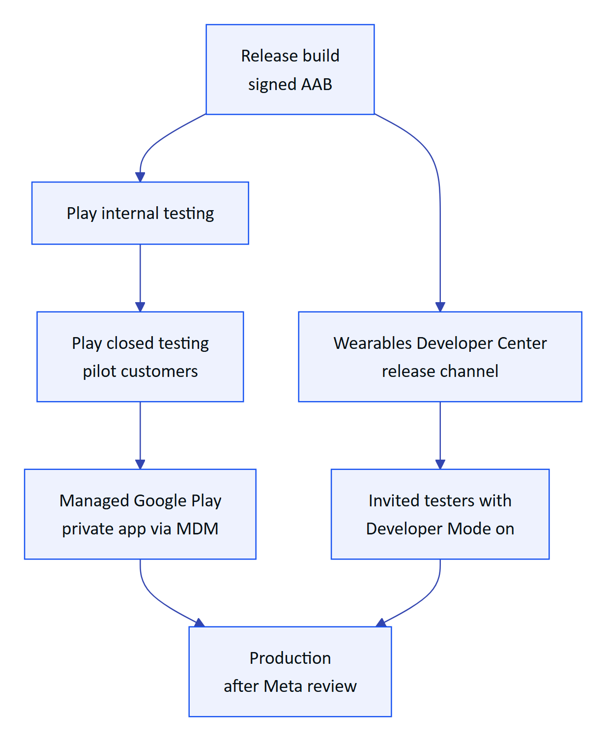
Figure 28. Release path from build to operators
Table 28. Distribution status
Channel | What it covers | Status
Direct APK (sideload) | Team devices and demos | In use
Google Play internal and closed testing | Phone features for pilot users | Planned (needs release signing and the Play data safety form)
Managed Google Play (private app) | Enterprise rollout through the customer's MDM | Planned
Wearables Developer Center release channels | Invite-only testing of the glasses features without publishing review | Planned (needs a Developer Center organization and app)
Public listing with DAT features | General availability | Blocked: Meta's FAQ says submissions are not open yet and will open "soon"

RISK
Full Wearables Developer Center access is limited to countries where Meta AI glasses are supported. Eligibility for Hydris's Indian pilots must be confirmed with Meta before planning a production glasses rollout. Phone features are not affected.

The Play data safety declaration must cover: camera images (processed on device, uploaded when the user sends a scan), audio (recognized on device or by the system recognizer; transcripts sent to Hydris), account information, and crash diagnostics once added.

17 Testing

17.1 Current state
There are no automated tests in apps/android yet (no src/test or src/androidTest). The scanning algorithm is shared with the web, where the same thresholds are exercised by the web test suite and the simulated glasses camera in apps/web/src/glasses/camera.ts. The bridge app README states that the page side was tested end to end with a stand-in bridge, and that DAT calls are type-checked but not yet run on physical glasses.

17.2 Test plan
Table 29. Planned test layers
Layer | Scope | Tooling
Unit | DocDetect (guidance, warp corners, parity with web fixtures), OcrEngine.prepare sizing, labelValues, wake and stop regexes, cookie jar expiry | JUnit, Robolectric for Bitmap
Networking | Refresh on 401, mutex ordering, session lost, device token refresh, SSE parsing and Last-Event-ID | OkHttp MockWebServer, Turbine
UI | Login states, alarm actions per state, scan stages, glasses steps | Compose UI tests
Screenshots | Every screen at font scale 1.0 and 1.3 | Roborazzi or Paparazzi
Glasses without hardware | Registration, permissions, camera stream, photo, capture button | DAT Mock Device Kit (mwdat-mockdevice, already a debug dependency)
Hardware | Ray-Ban Meta Gen 2 and Oakley Meta, phone matrix | Manual, per the QA test plan (HFG-QA)
End to end | Demo deployment, scripted round | Manual for pilot, automated later

NOTE
Meta's FAQ states that the Mock Device Kit does not support display glasses. That does not affect Hydris Field, which targets camera glasses.

18 Feature status and roadmap

18.1 Status summary
Table 30. Feature status
Feature | Status
Sign in, demo mode, session restore, sign out | Built
MFA, org switch, server picker | Planned
Home dashboard | Built
Alarms list, detail and lifecycle actions | Built
Alarm notes, history, SOP links | Planned
Inspections list | Built (read-only)
Running inspections on the phone | Planned
Maintenance list and checklist toggles | Built
Maintenance start, hold, complete | Planned
Sensors list and history chart | Built
Audit scan: phone camera, glasses camera, import, guided capture, two-pass OCR, upload | Built
Audit document list | Built
Audit review and approval in the app | Planned (console only)
Hydris assistant: text, Hey Hydris on phone and glasses, spoken answers | Built
Voice Invocations ("Hey Meta, start Hydris") in the native app | Planned (implemented in the bridge app only)
Glasses connect, test, register, unregister | Built, not verified on hardware
Realtime alarm notifications while open | Built
Push notifications when closed | Planned
Offline cache and outbox | Planned
Automated tests | Planned
Release signing and Play distribution | Planned

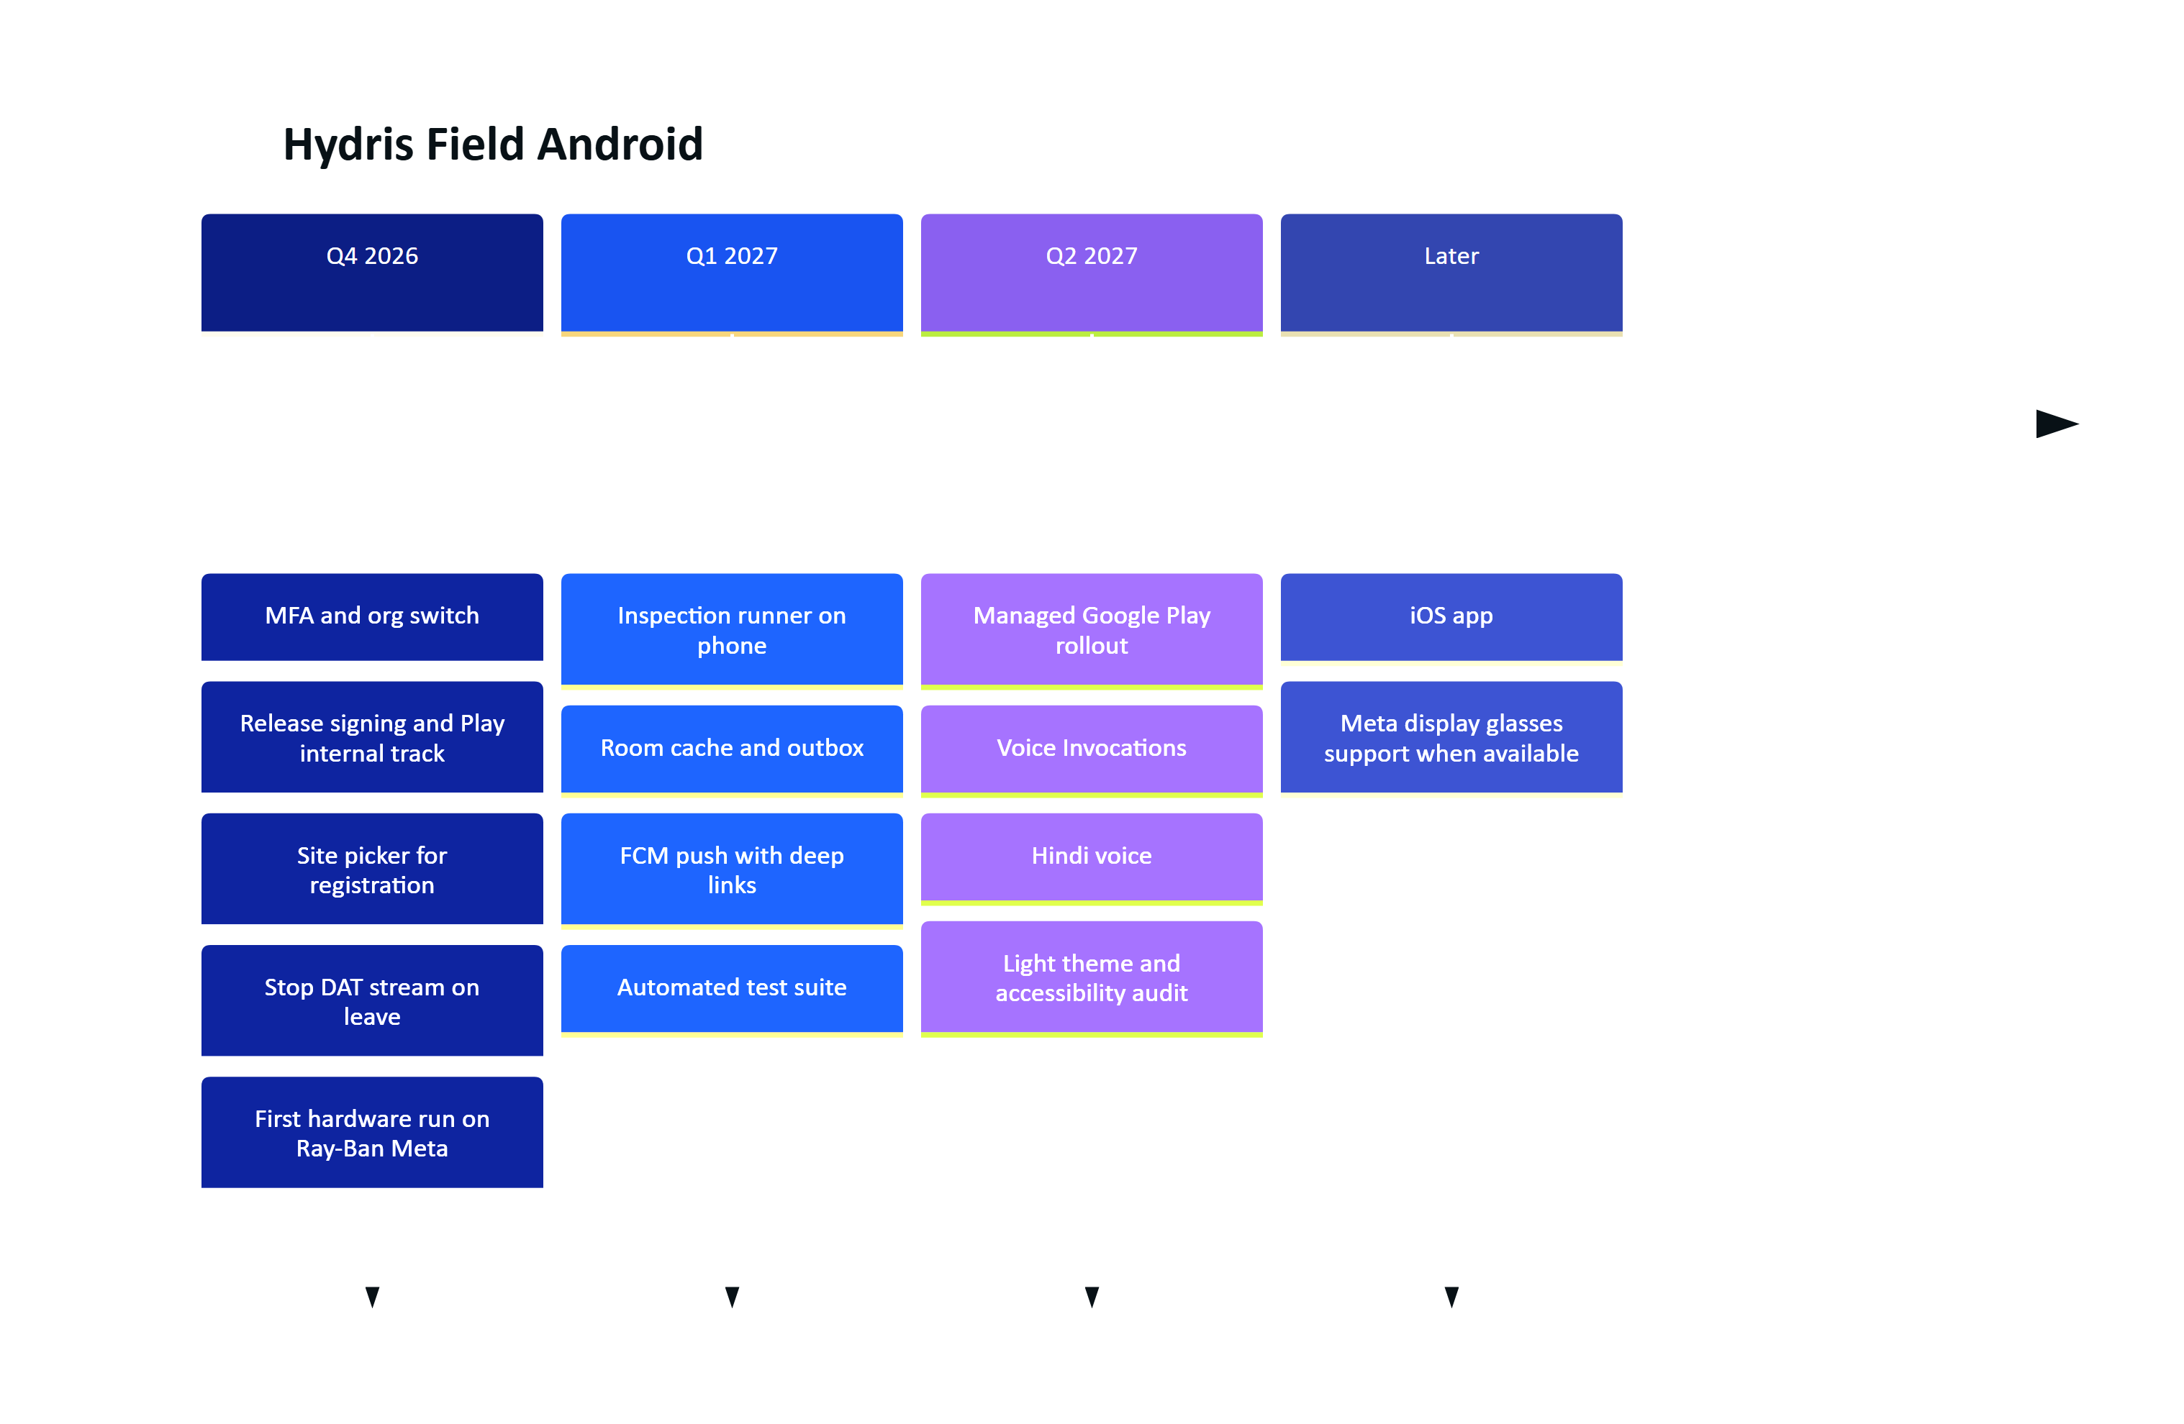
Figure 29. Mobile roadmap (indicative quarters)

18.2 Open questions
- Should the phone app become the only companion for display glasses as well, replacing apps/glasses-bridge-android, or should the WebView bridge remain for Meta Ray-Ban Display web apps? (See the Glasses Integration document.)
- Which customer MDMs must be supported at pilot (Intune, Workspace ONE, Google endpoint management)?
- Is MFA mandatory for field operators at the first pilot site? If so, in-app MFA moves to the top of the plan.

